Name: Loic Curtis

**Task 1: Setting Up and Configuring User Accounts**

Open 365 admin center and select add multiple users from the active users

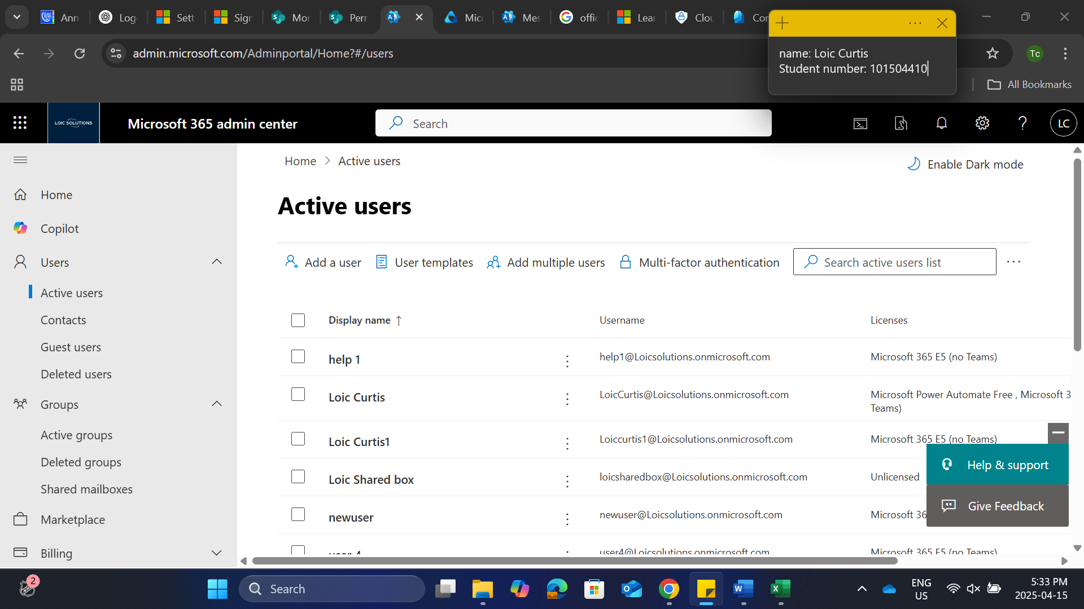

Click upload csv

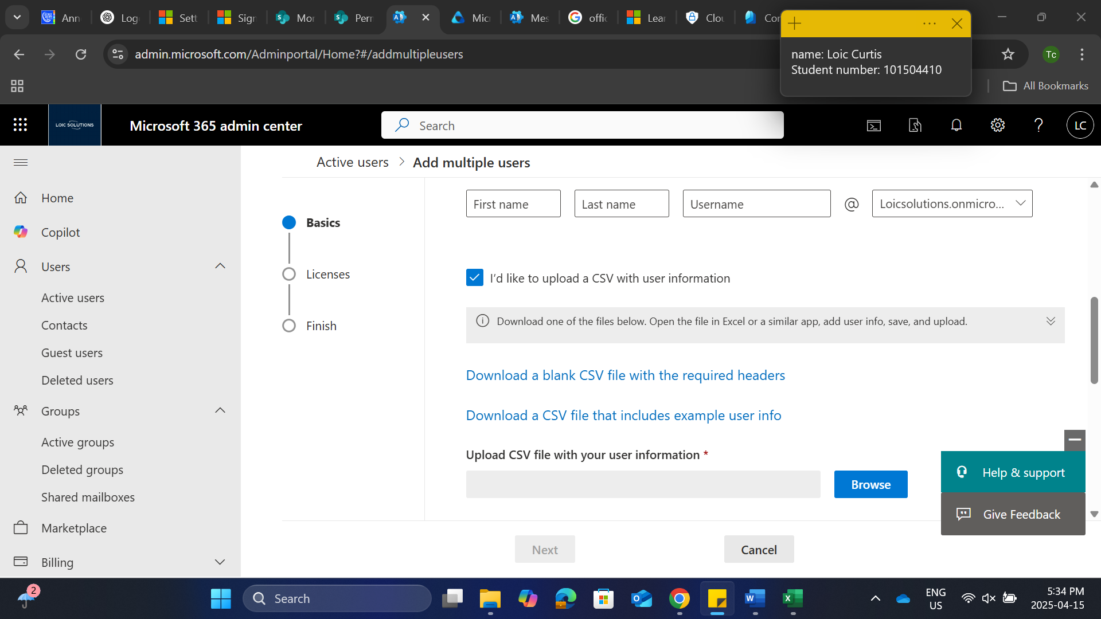

Here is my csv file for my users created with notepad

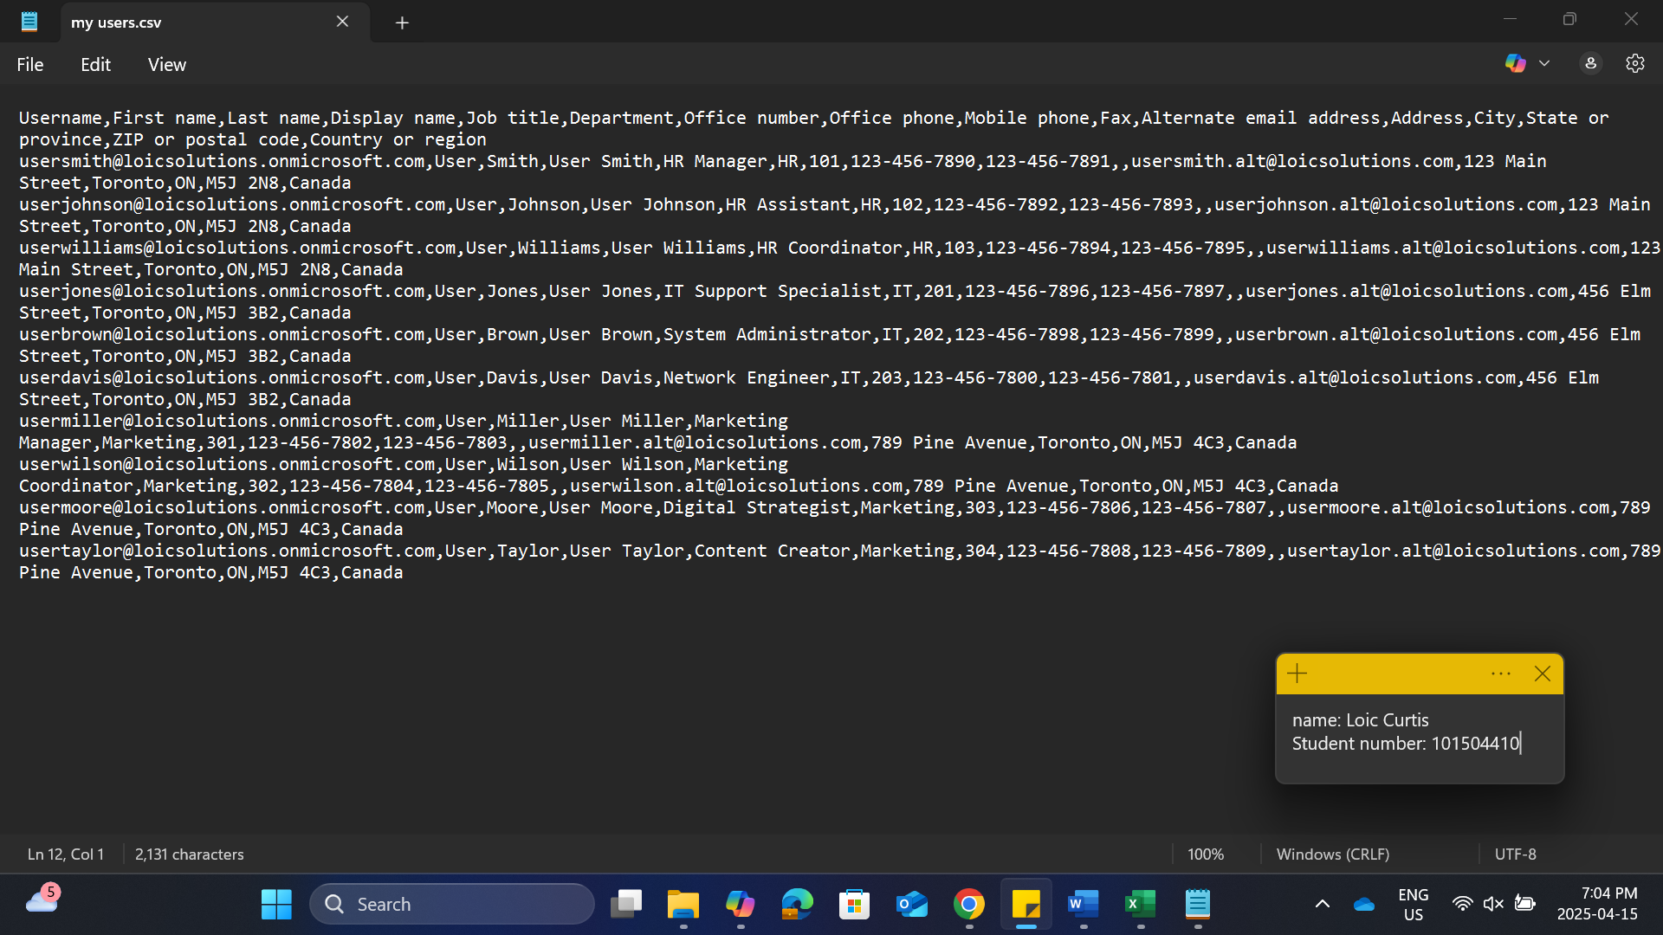

After uploading csv file, click next

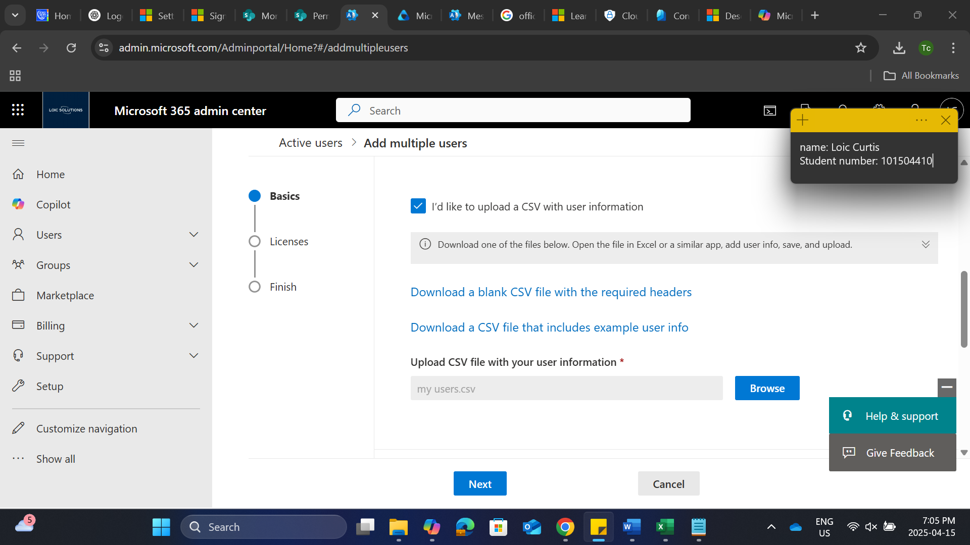

Click add users

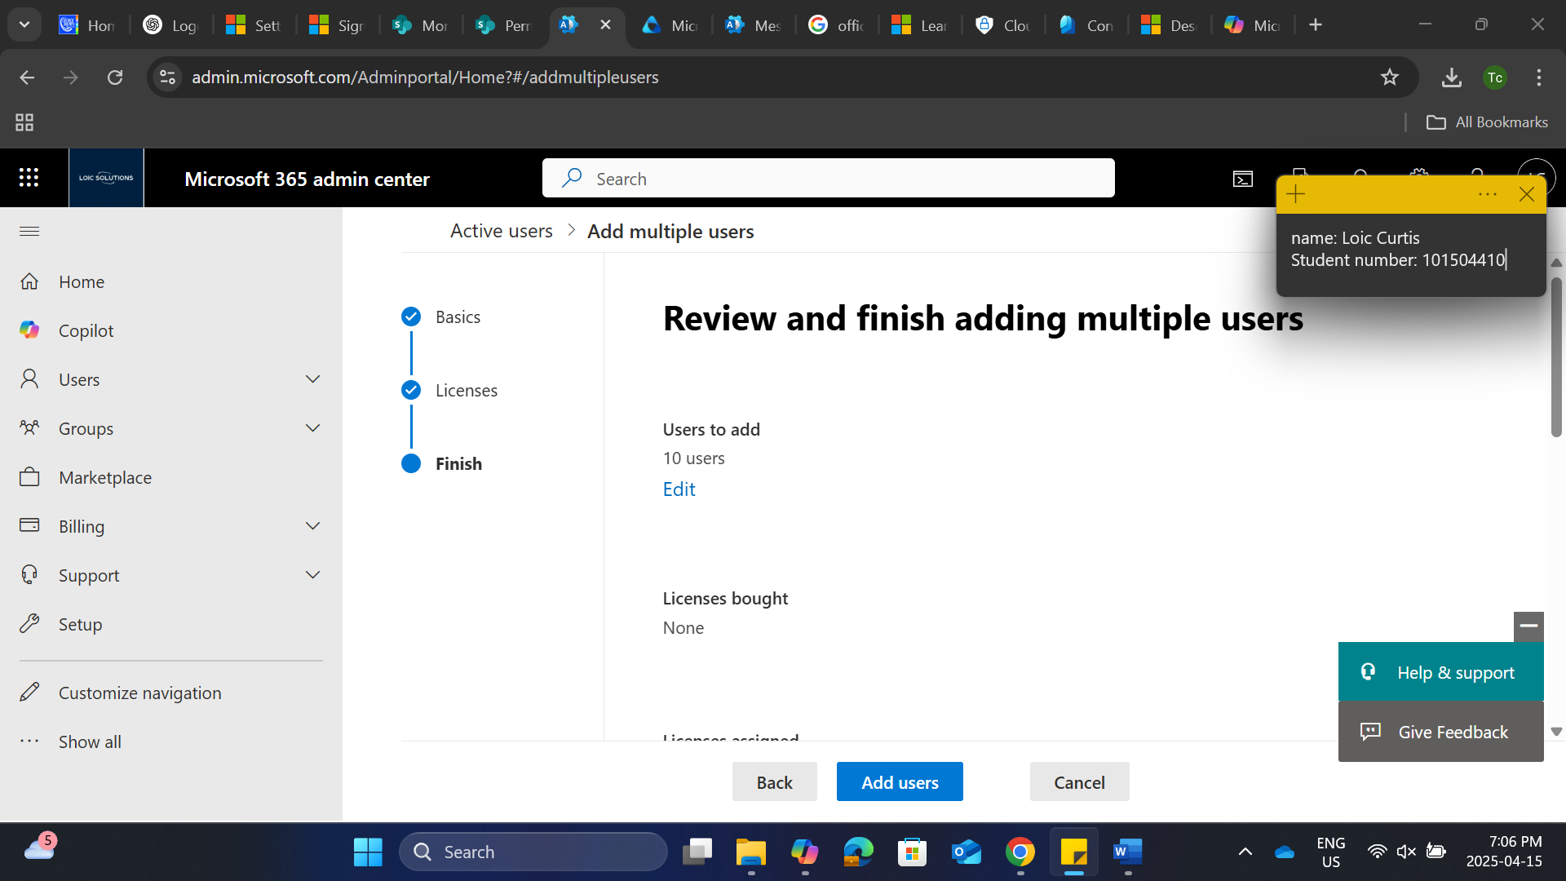

10 new users successfully added

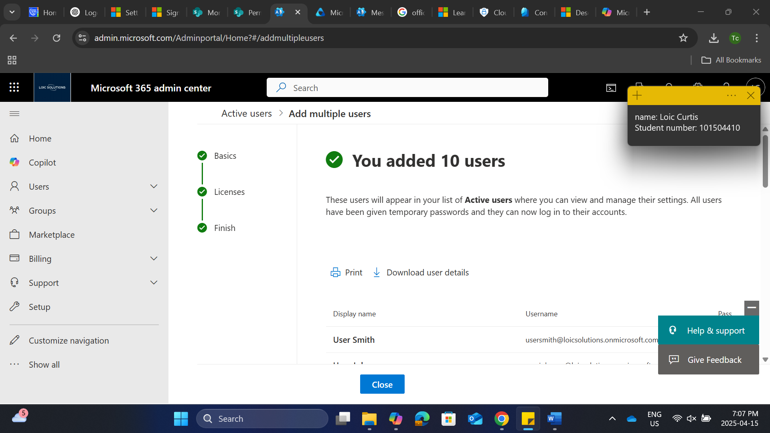

**Task 2: Monitoring and Reporting**

1. **Configure Audit Logs**:

Under purview admin center, select audit

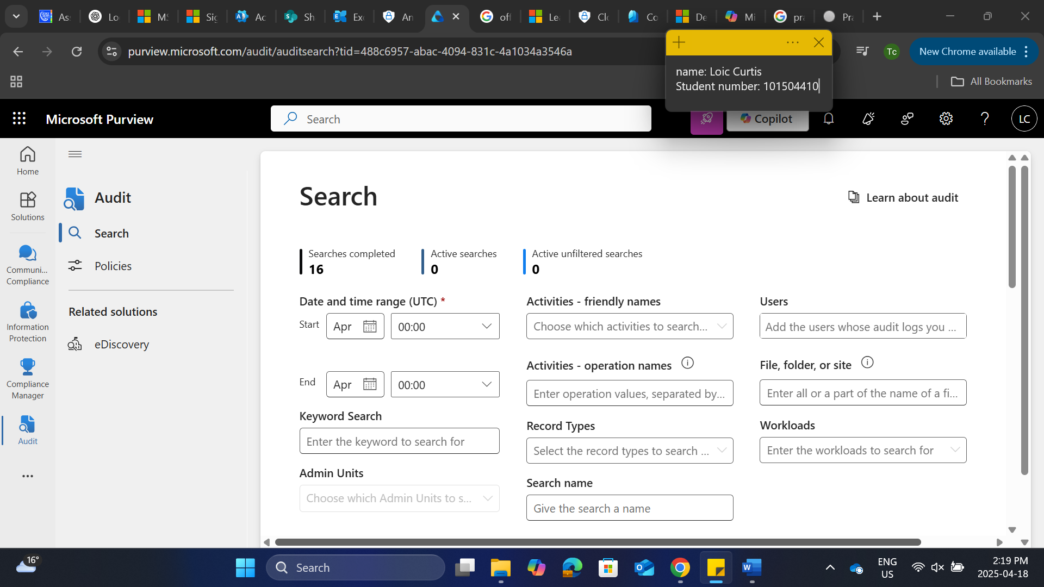

If you get any results you can view them to check

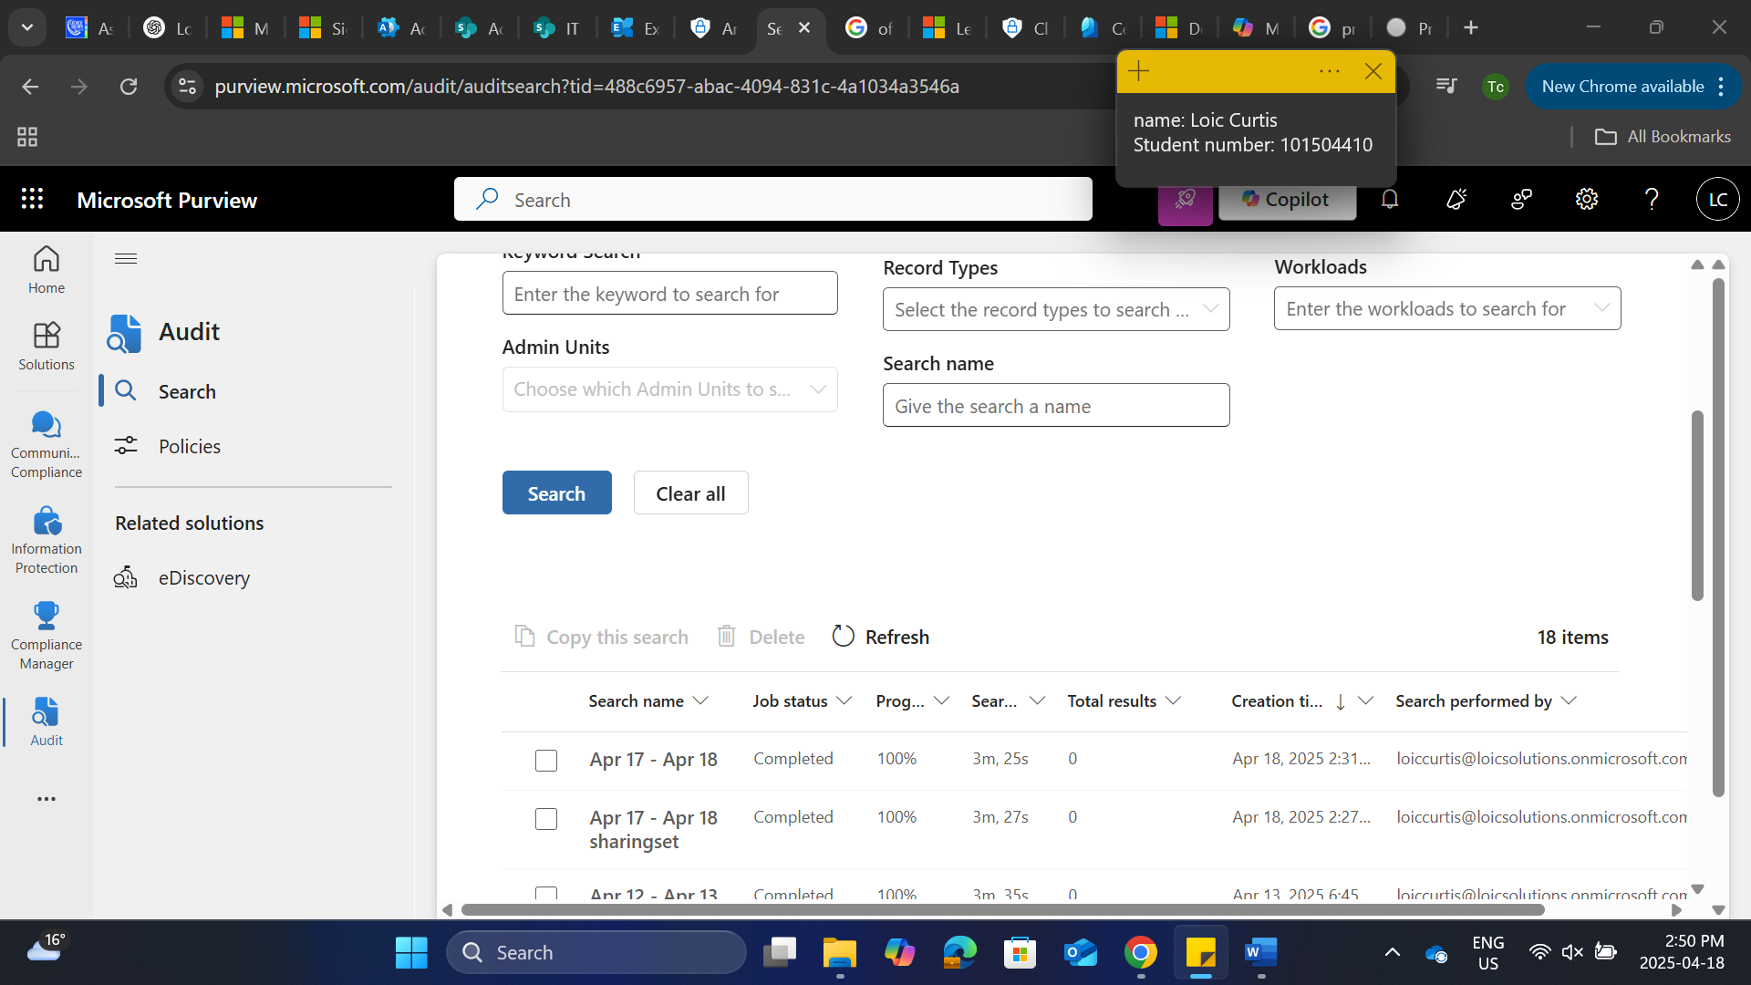

1. **Set Up Alerts**:

Open defender and select policy and rules under email and collaboration

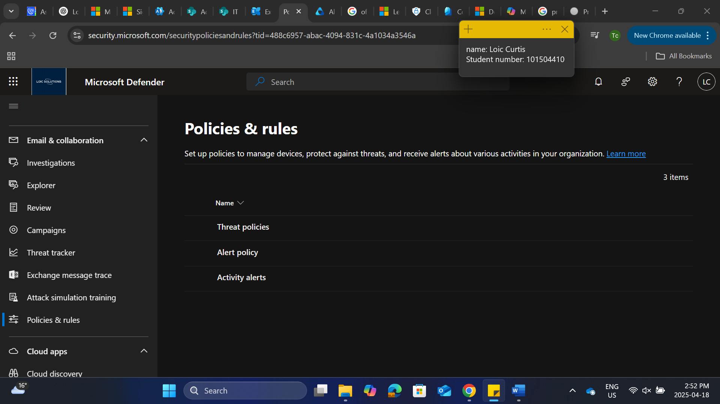

Select alerts and create new alert policy

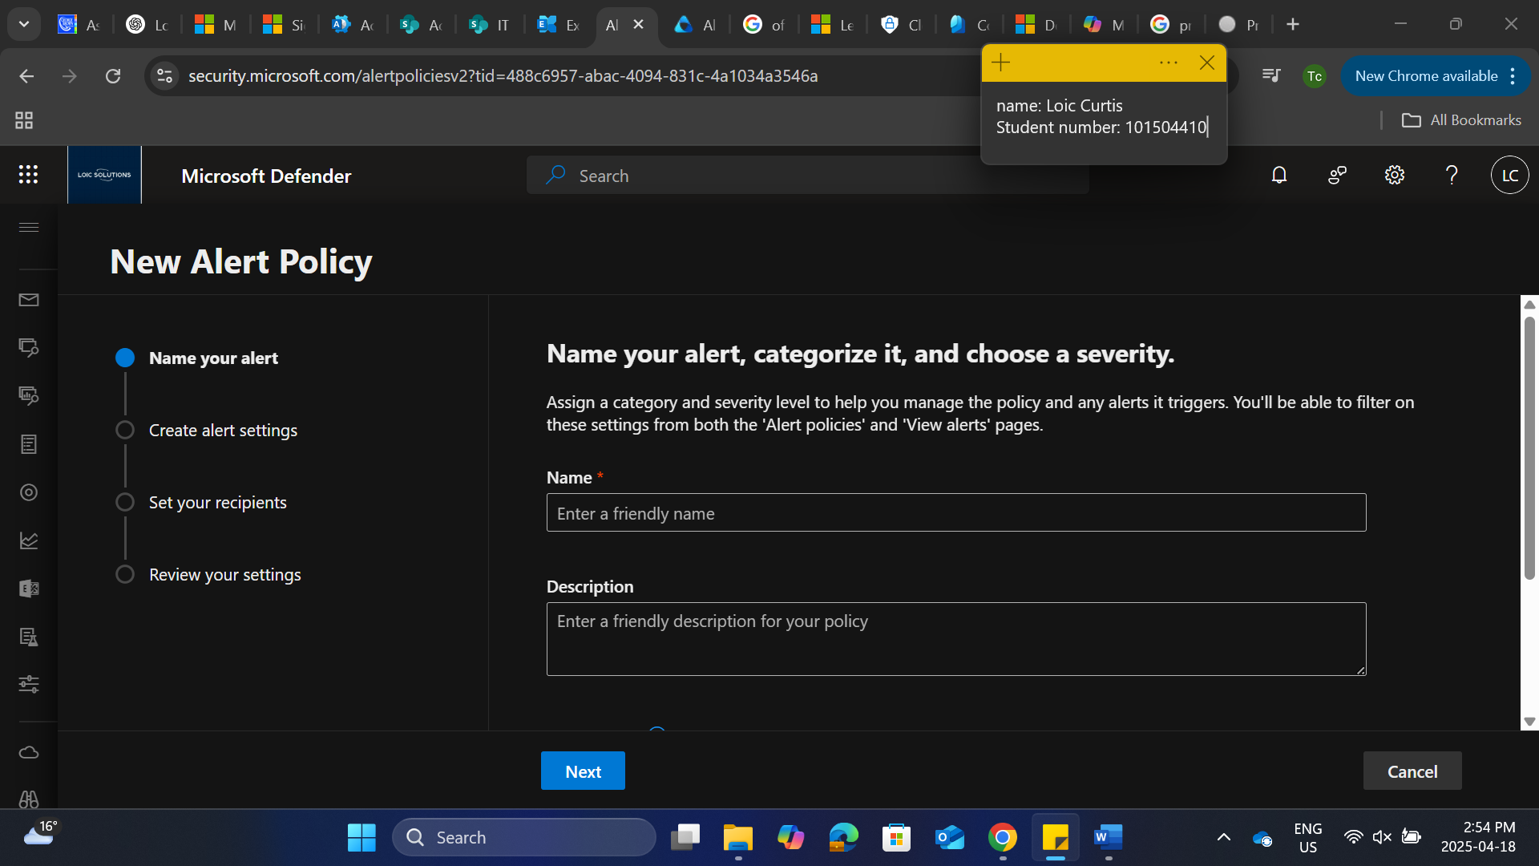

Alert name

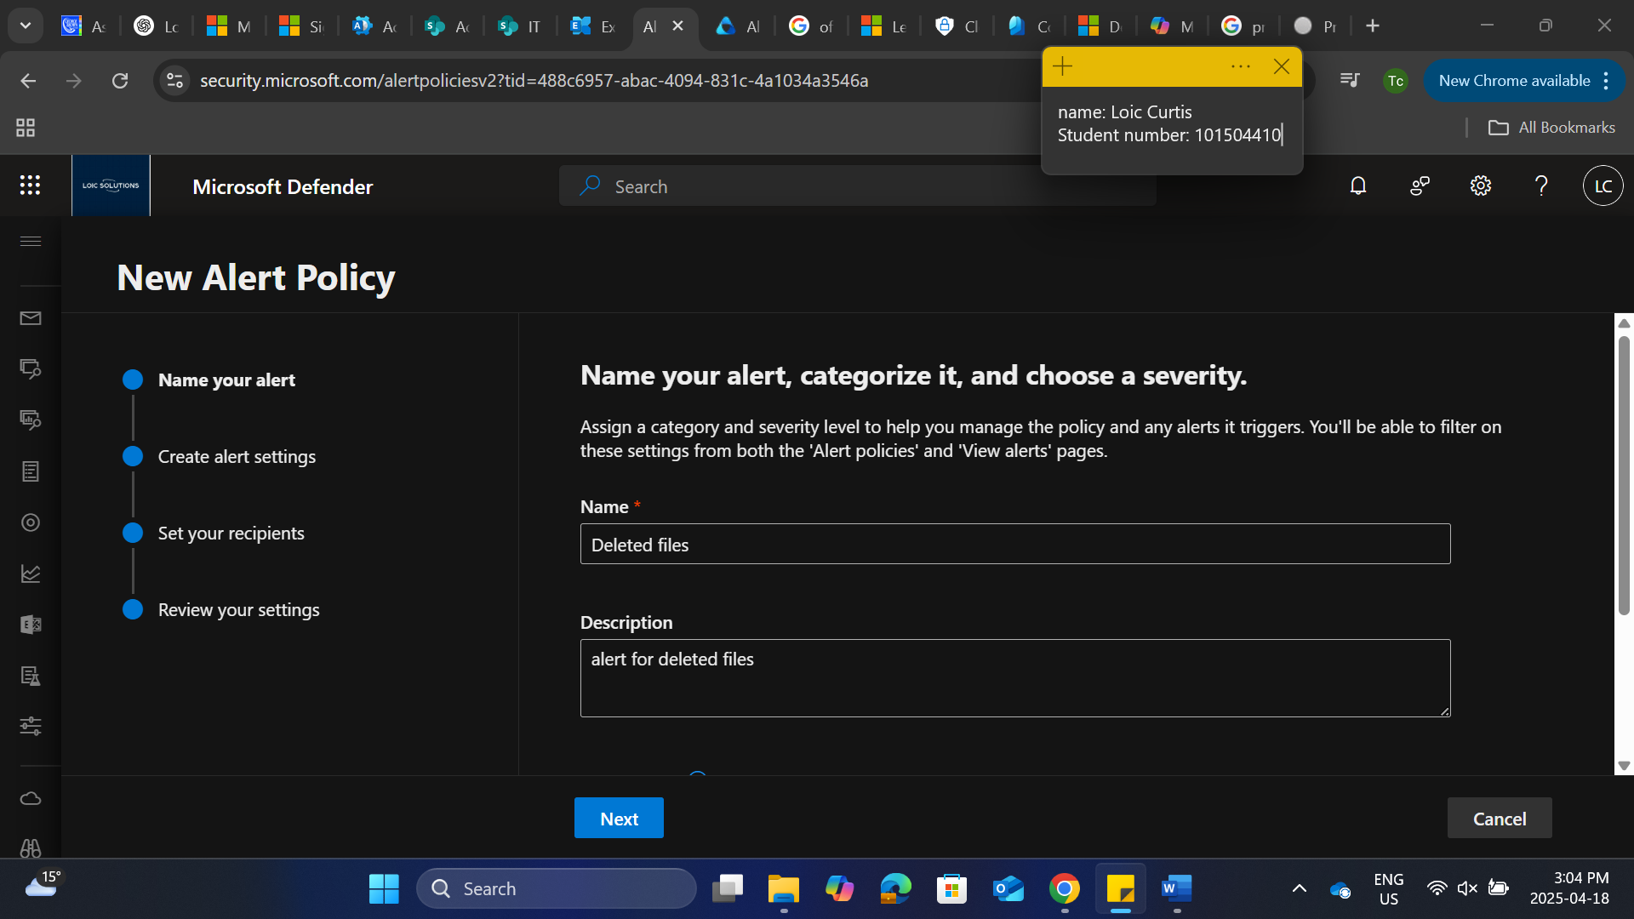

Select the alert activity

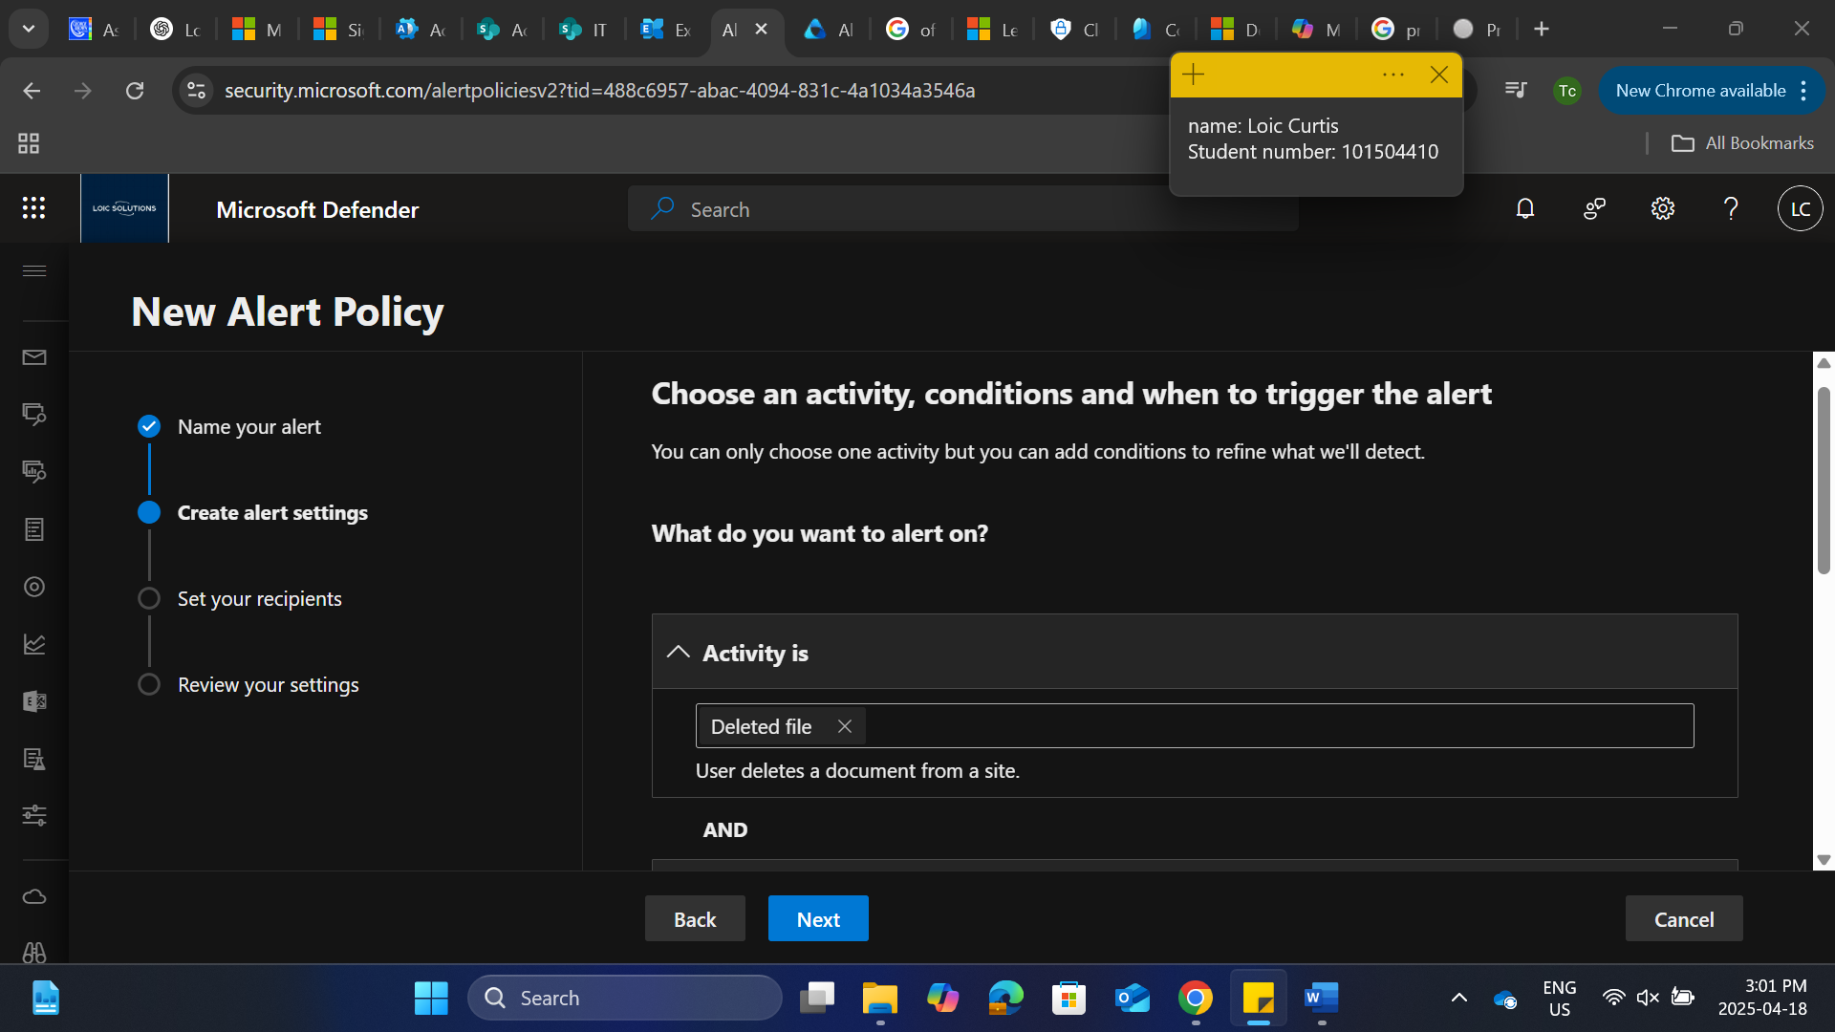

Select how you want the alert to be triggered

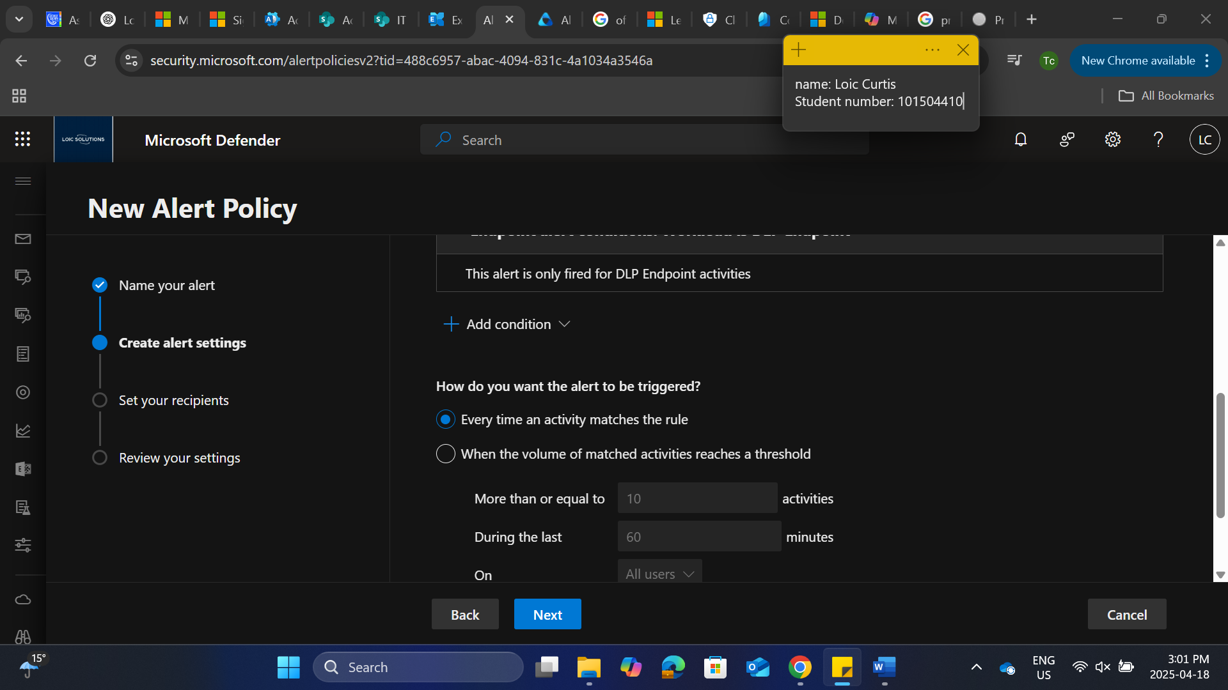

Select at least 2 global administrators to receive the alerts

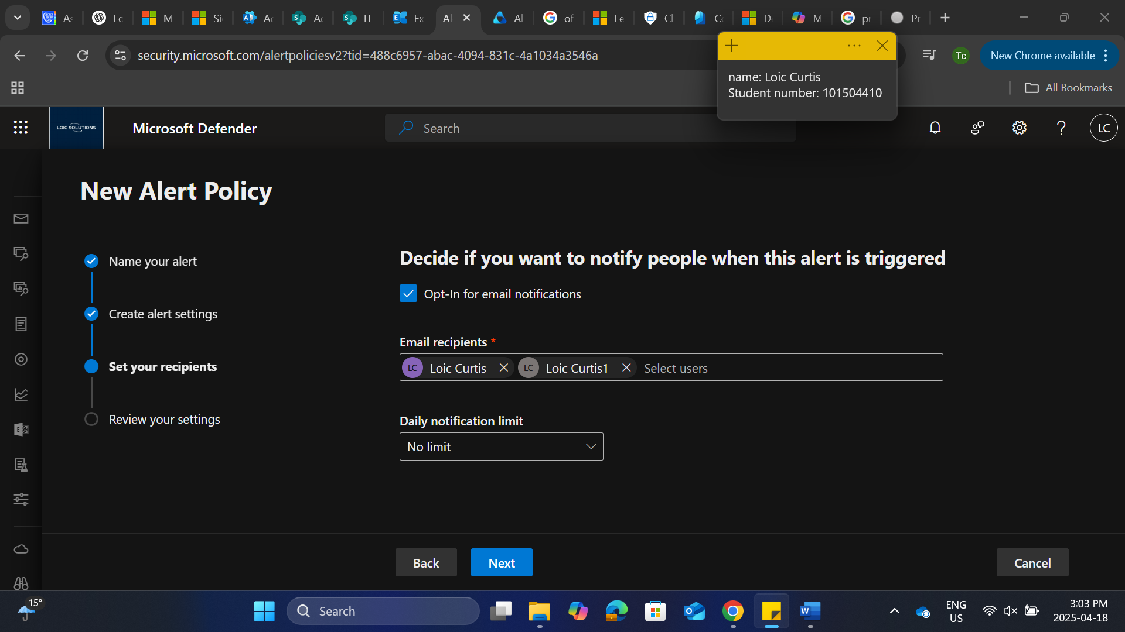

Select turn policy right away and select submit

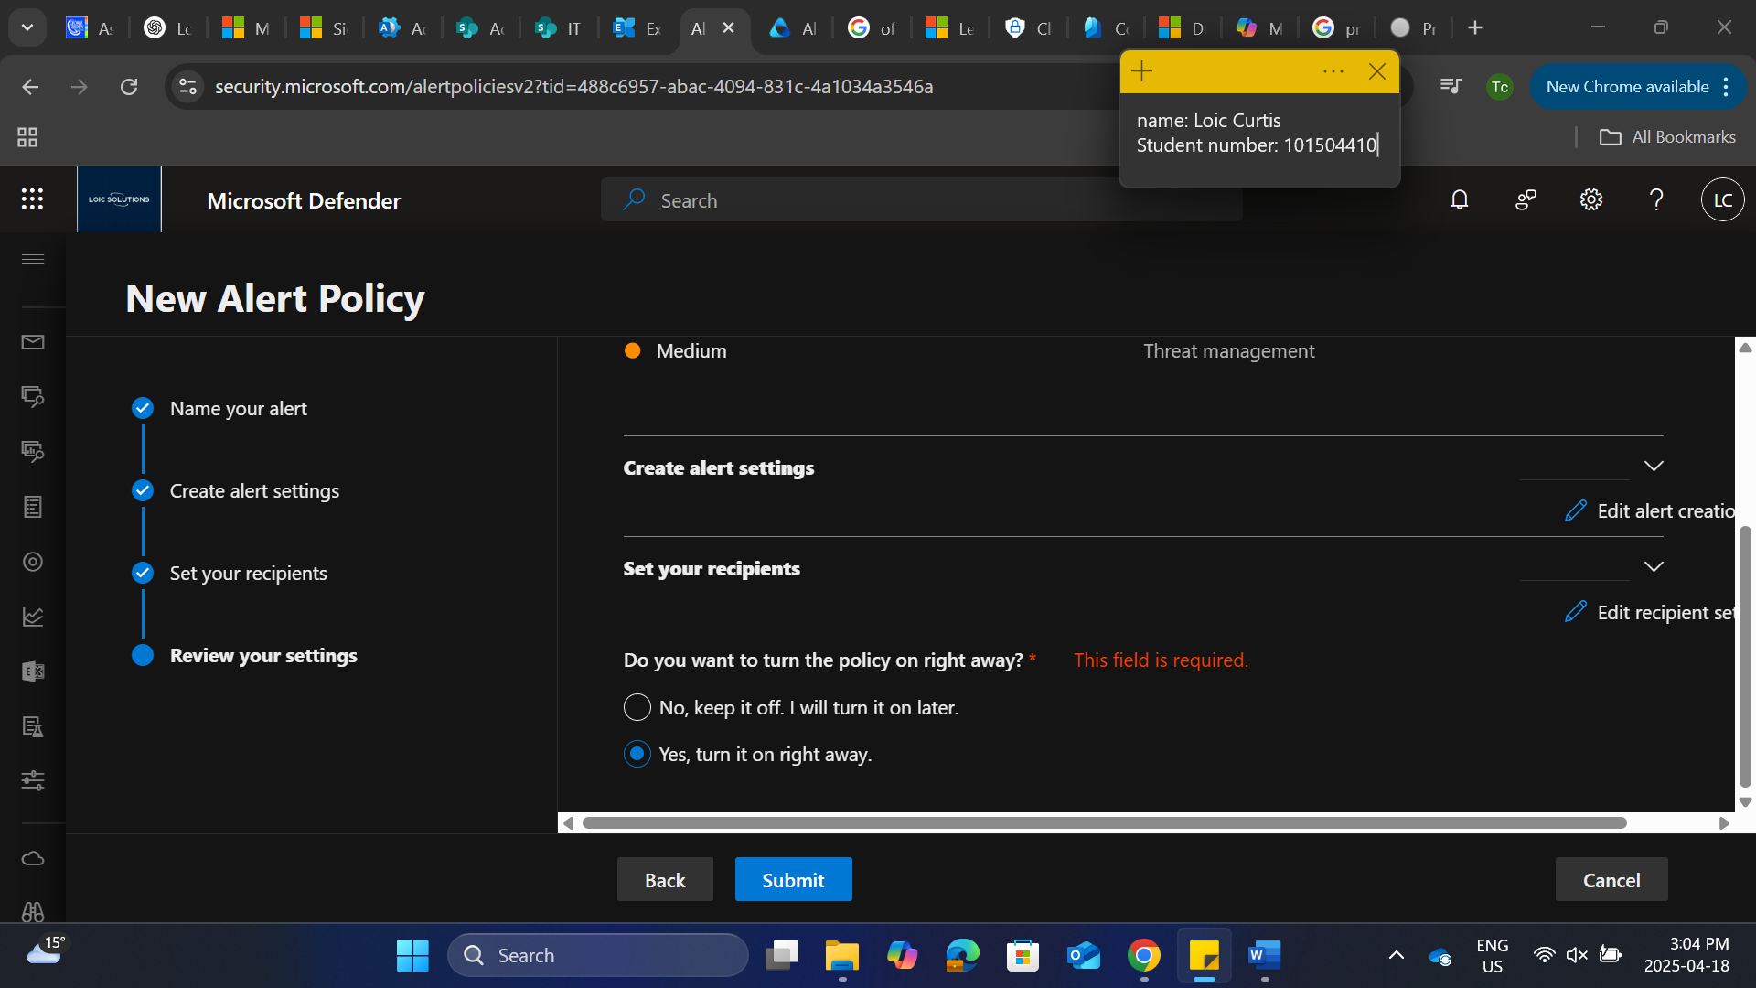

Alert has been created

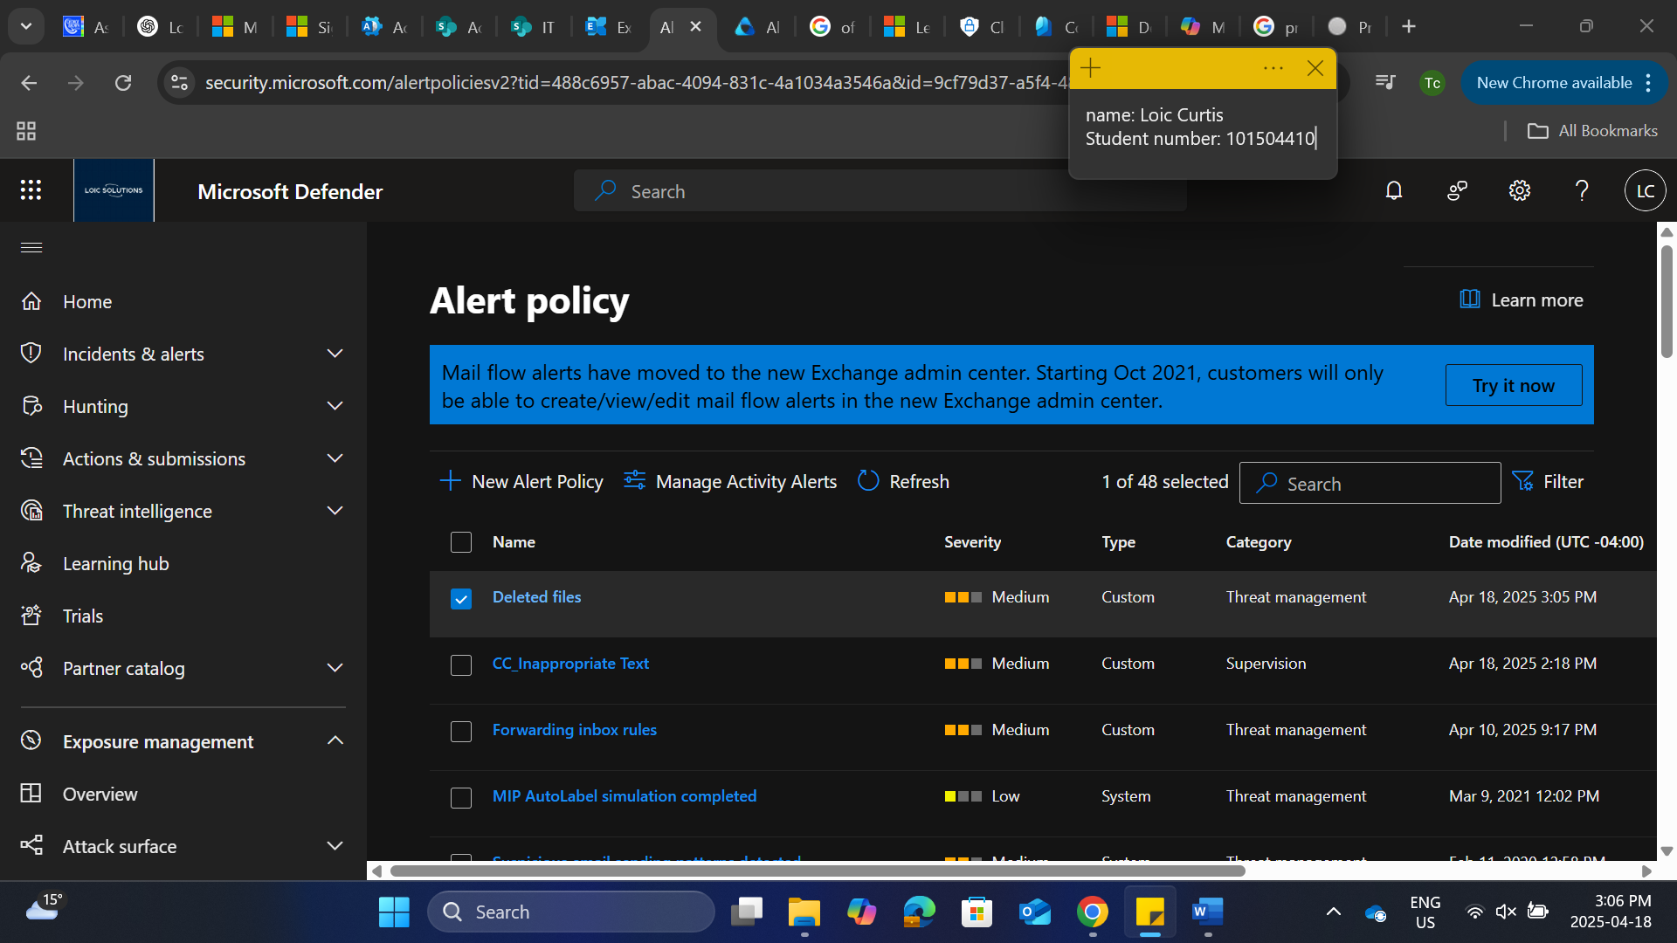

Under purview, select insider risk management

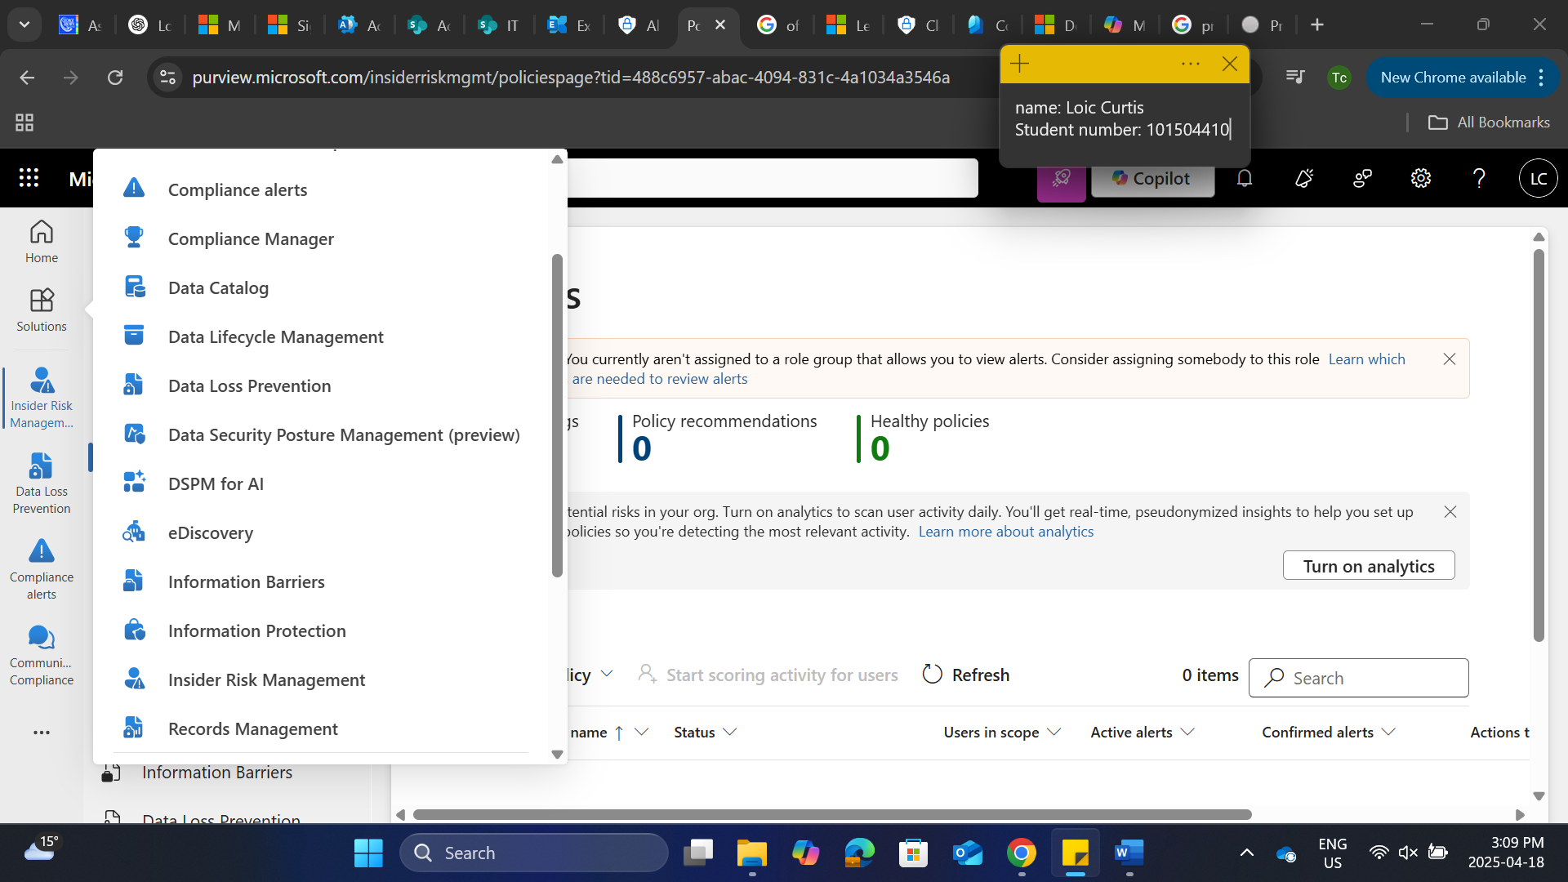

Select custom new policy

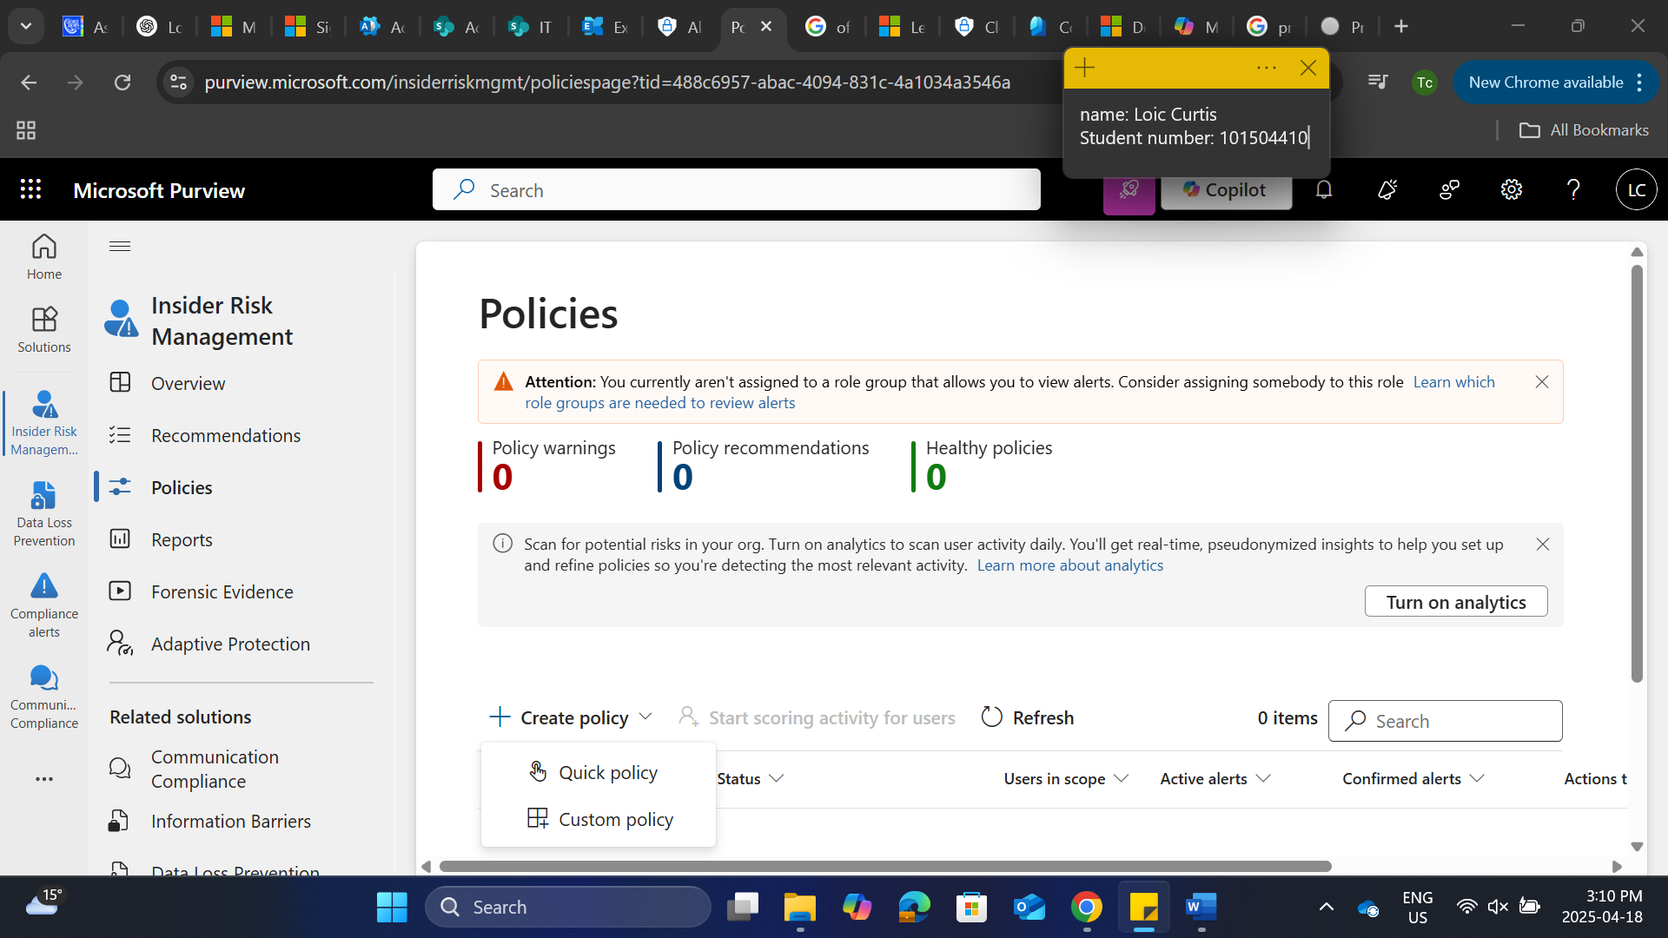

Review the template and select next

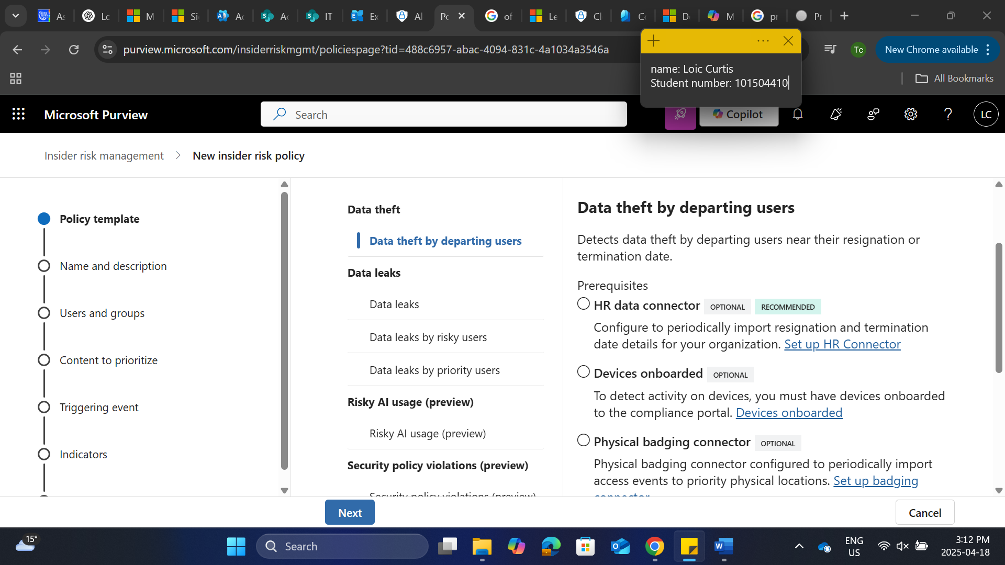

Name the policy

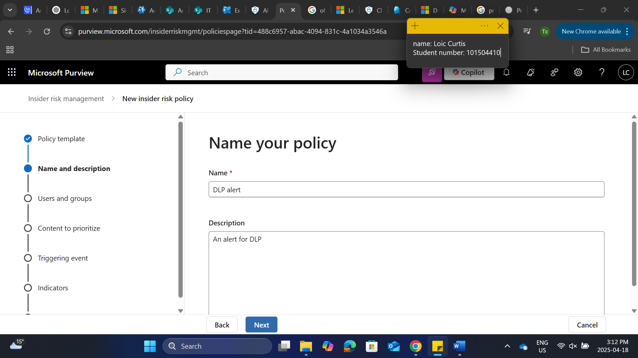

Select all users and groups

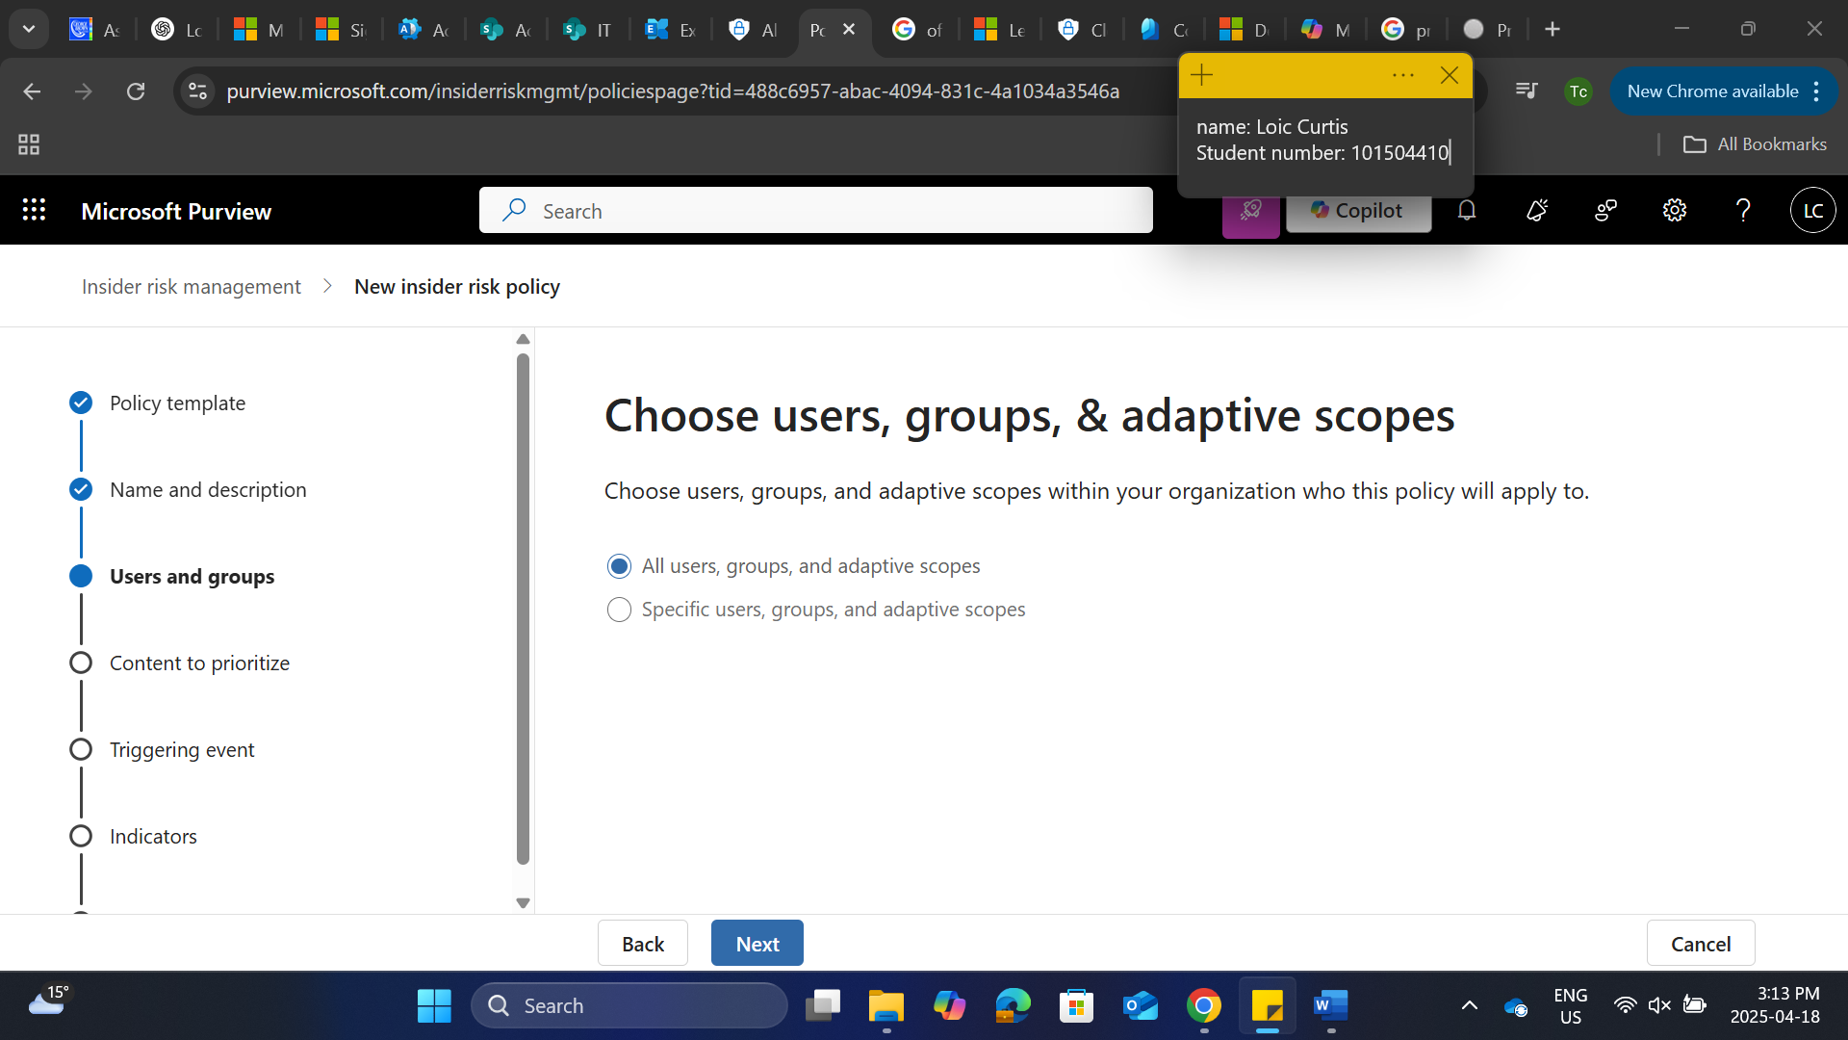

Select the triggering event

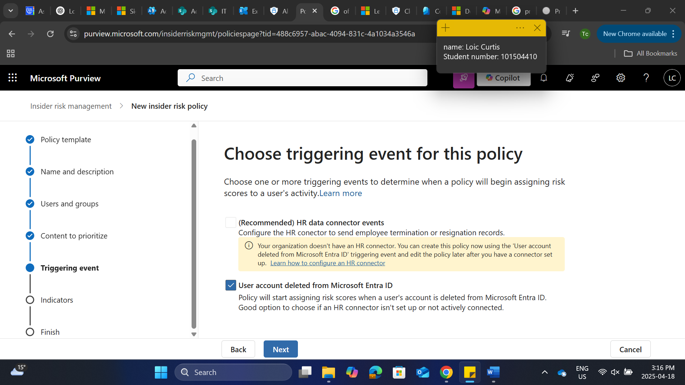

Select alerts from selected dlp policies

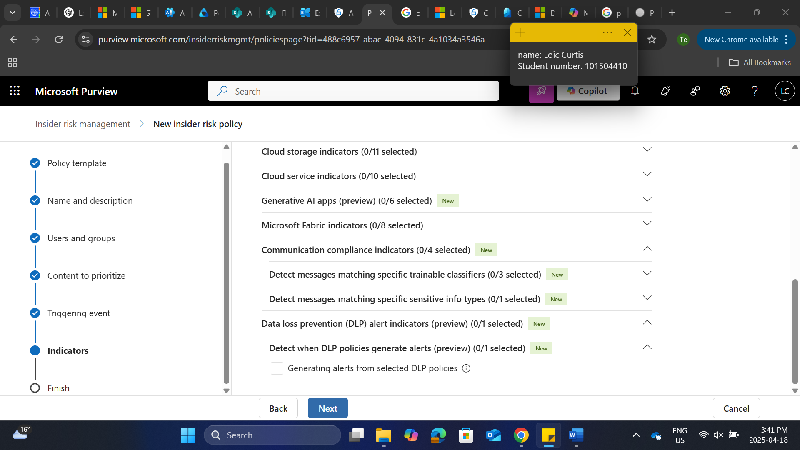

Detection options select all

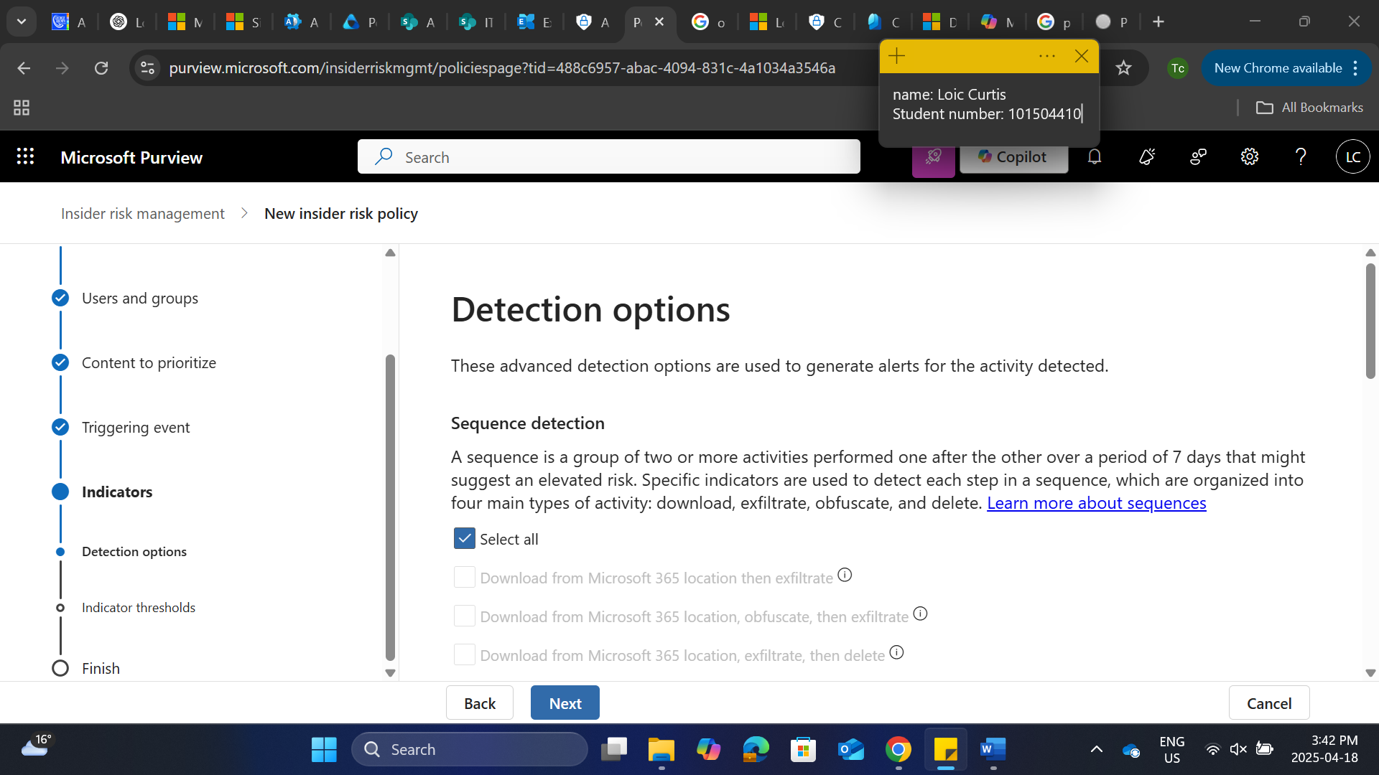

Choose threshold type for indicators

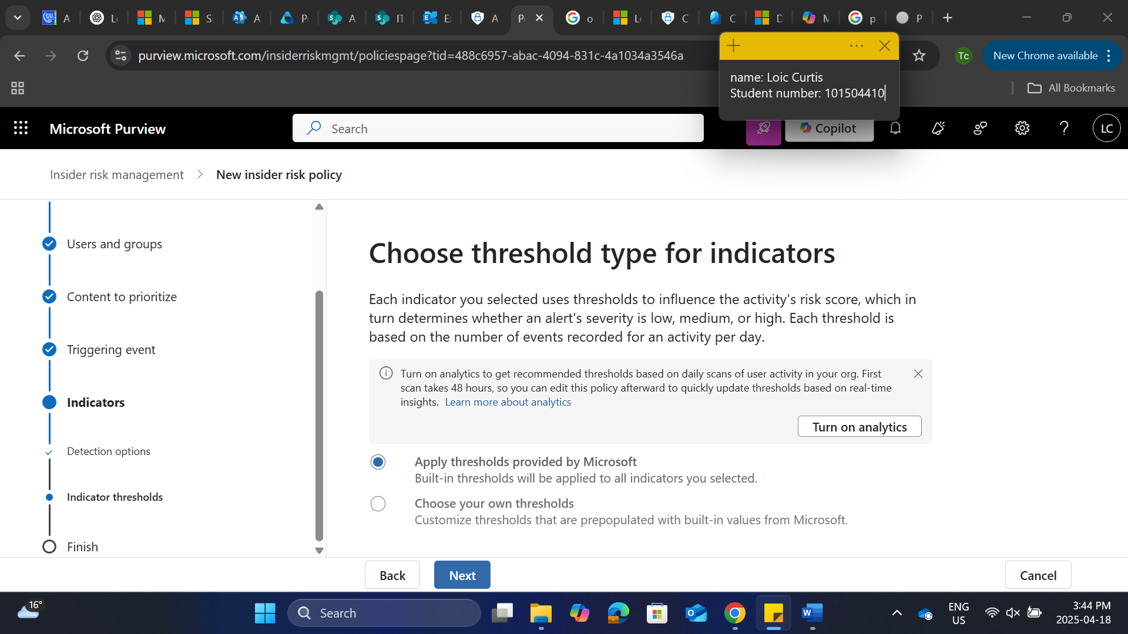

Review and submit

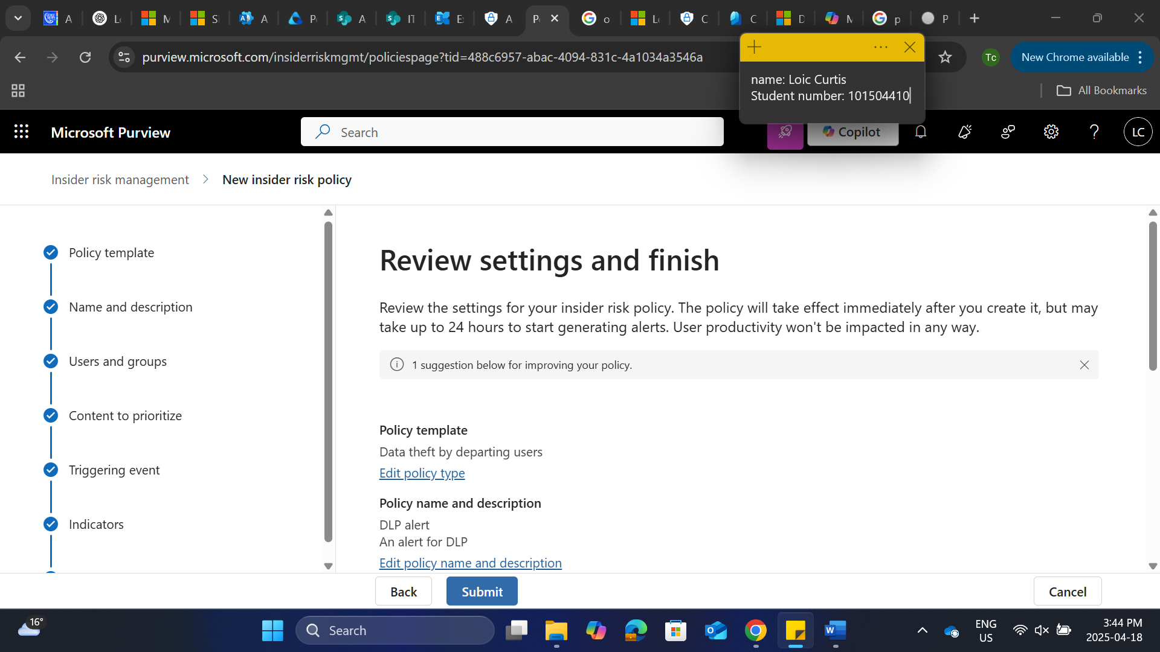

Policy has been created

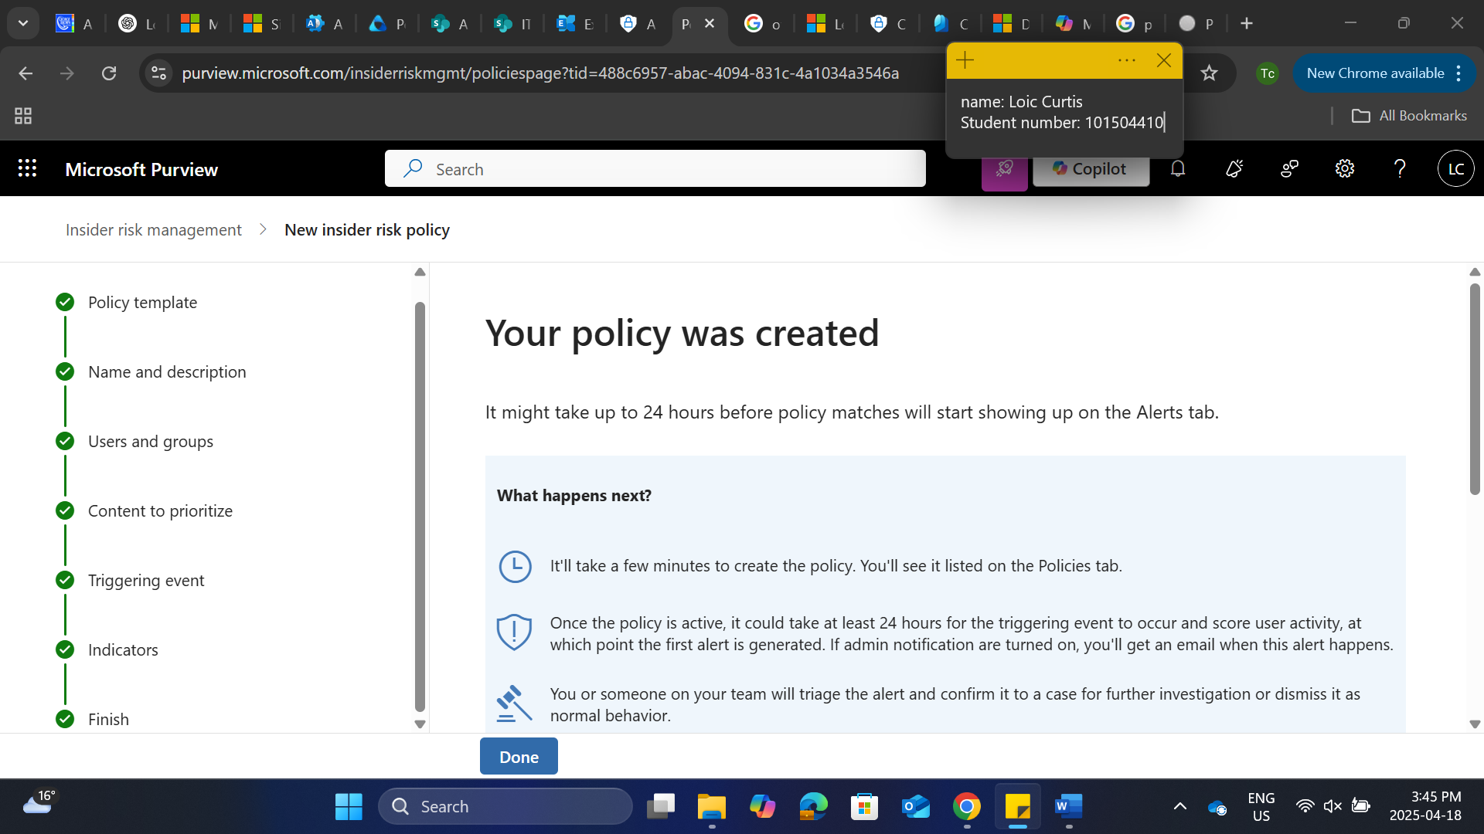

1. **Generate Usage Reports**:

Go to Microsoft 365 admin center, under reports select usage

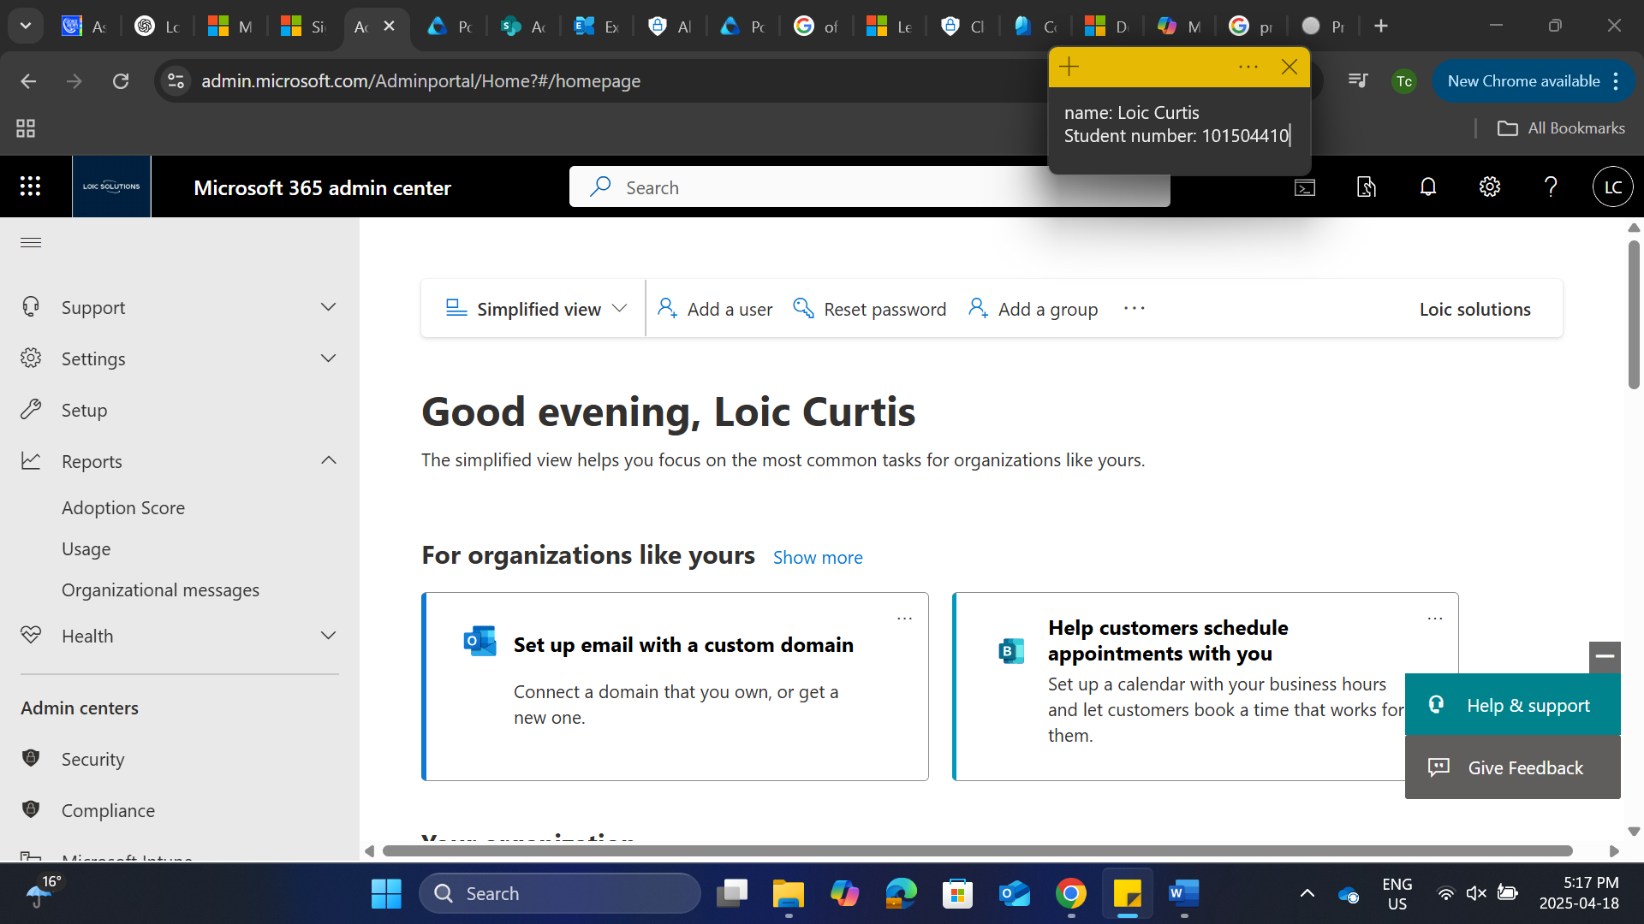

Email usage report

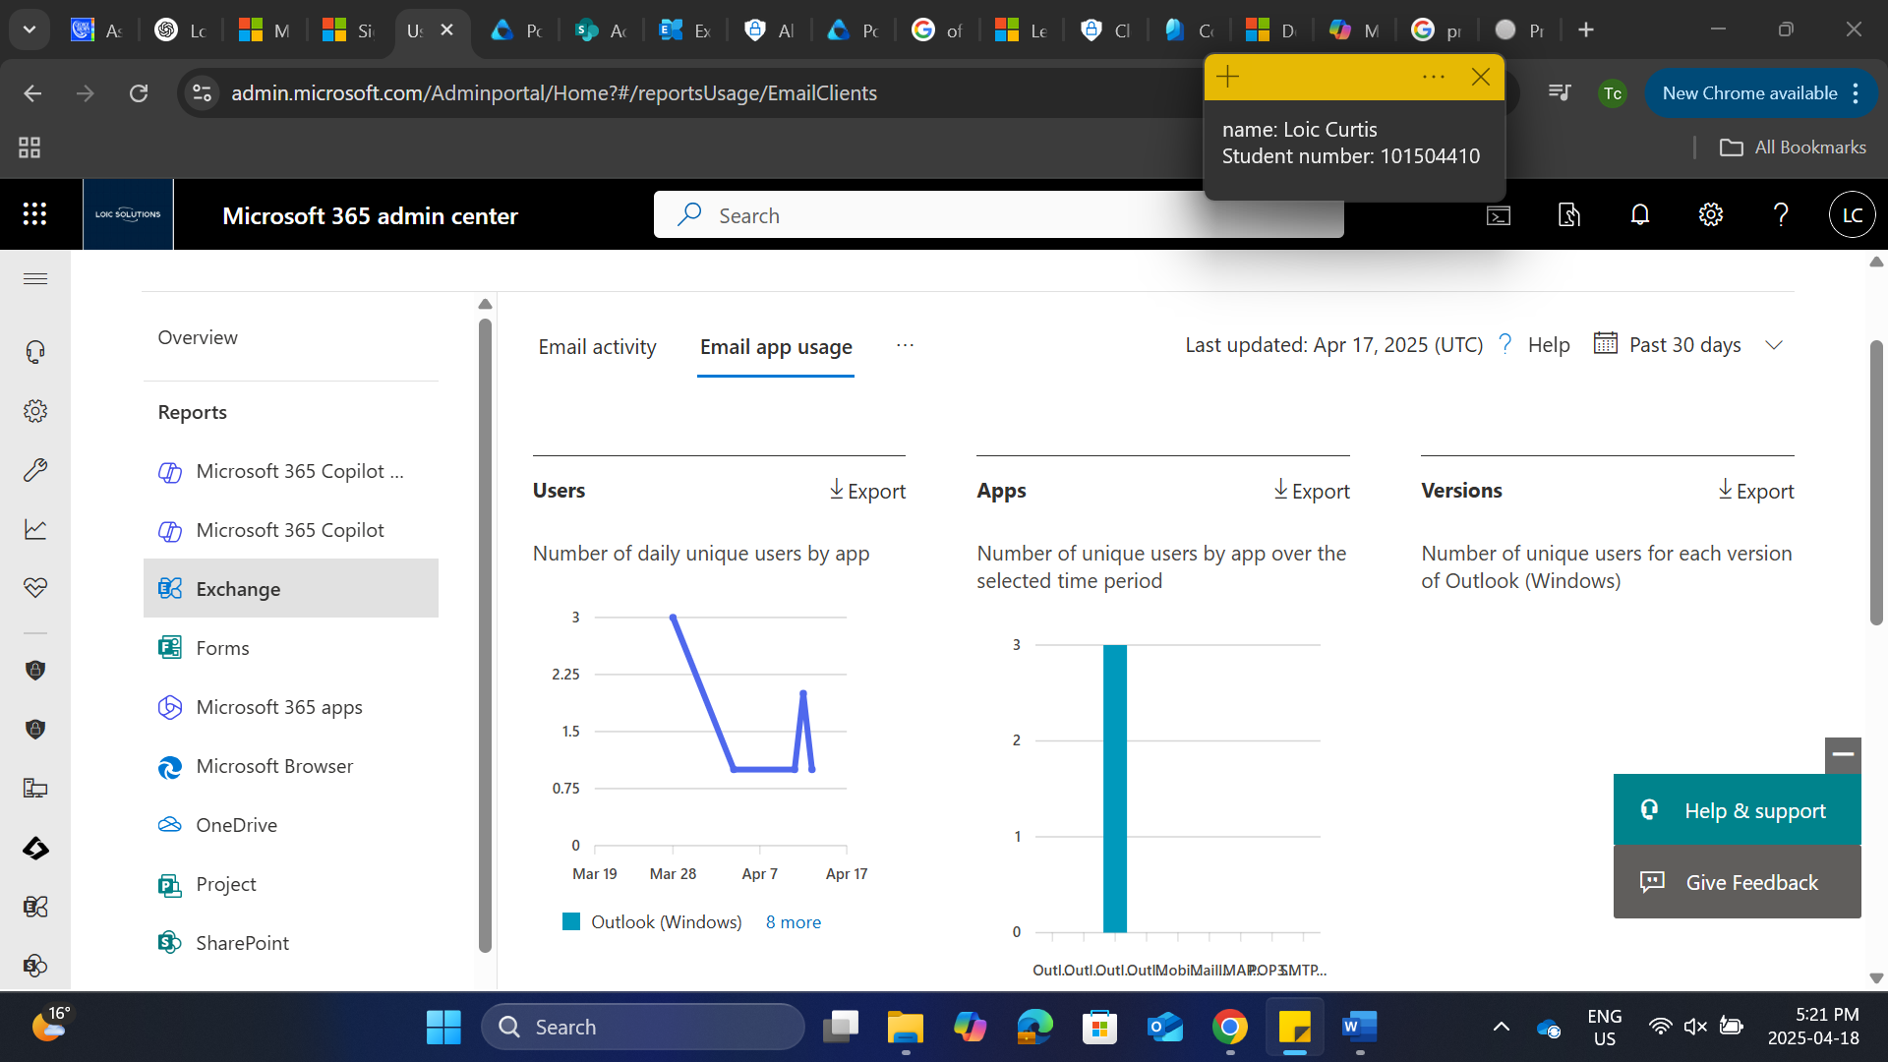

Sharepoint site usage report

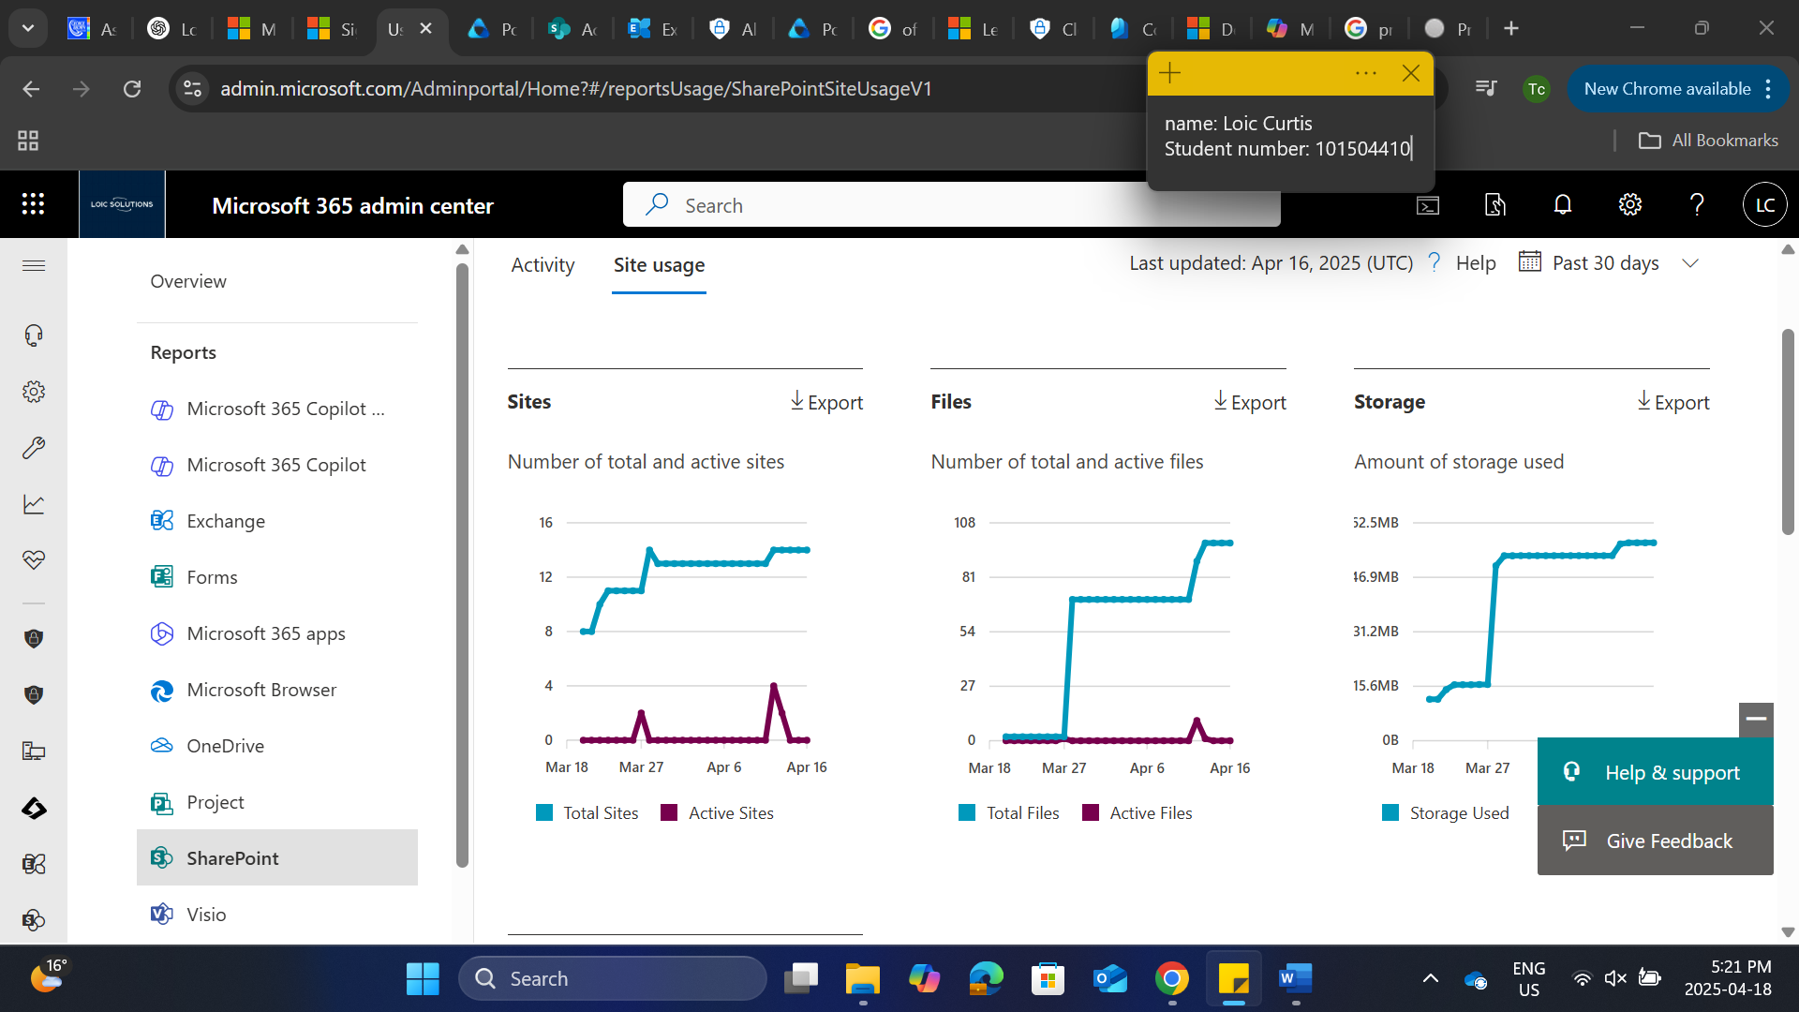

Signing into the power automate platform

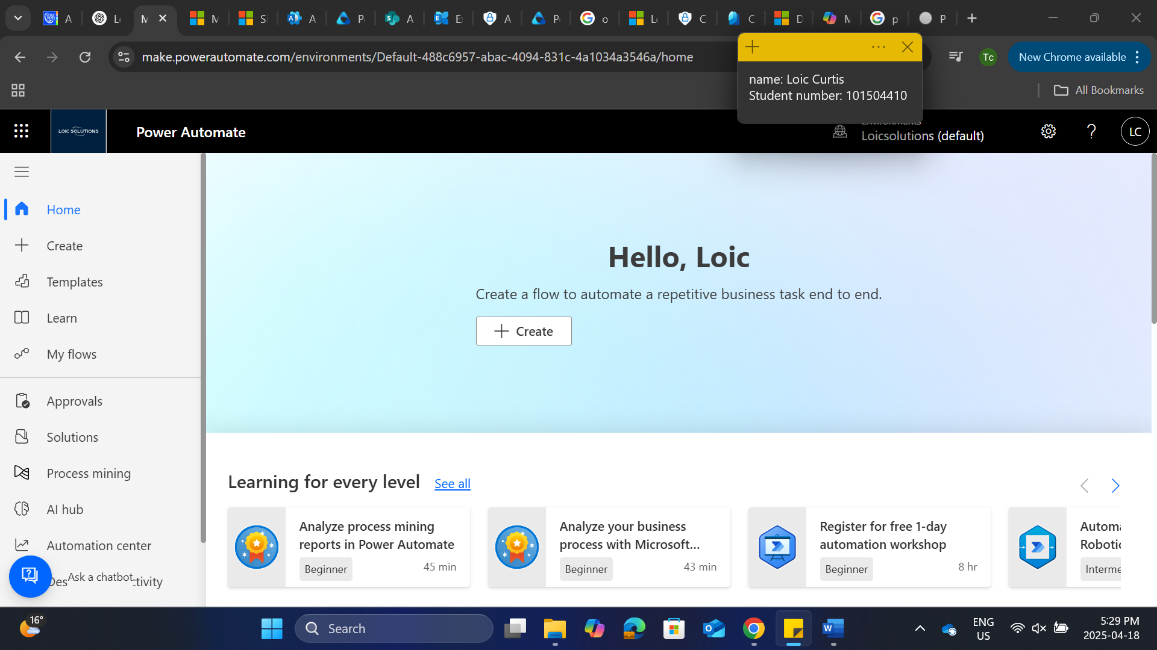

Select create and select schedule cloud flow

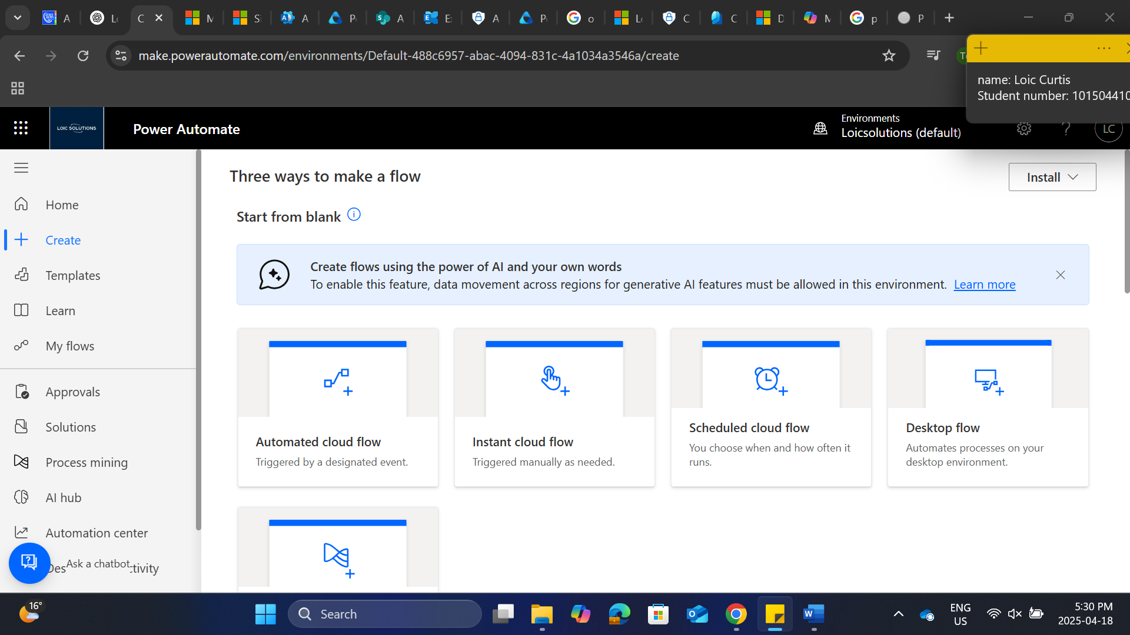

Configure the flow and select create

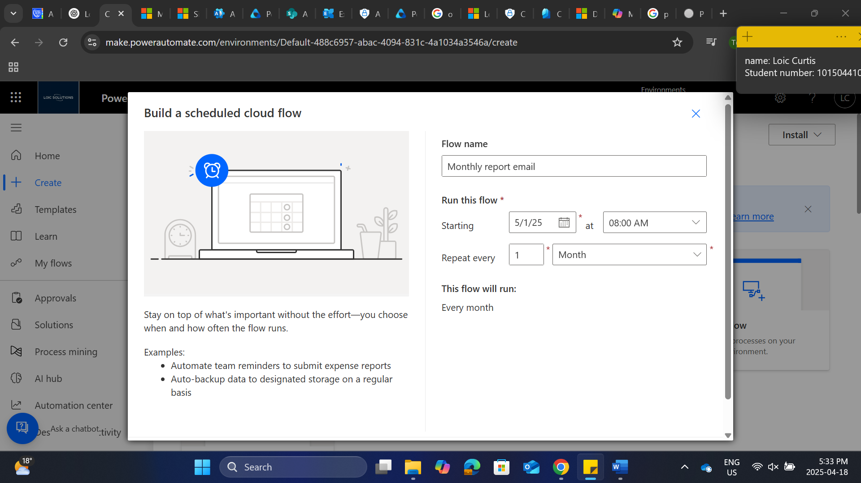

Select the plus sign below recurrence to add an action

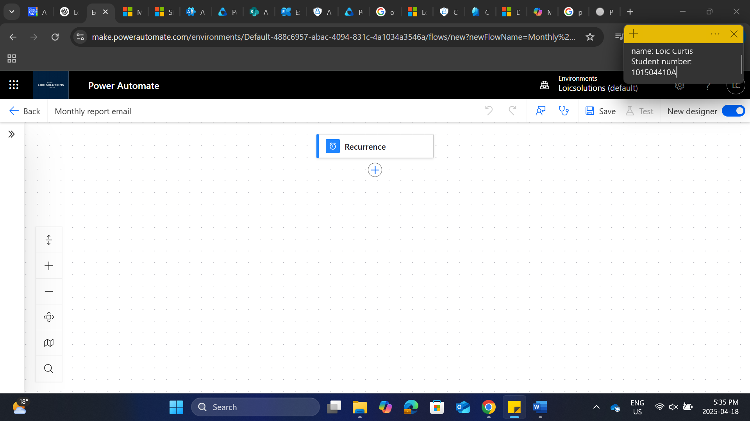

Under action, select get file content and sign into outlook

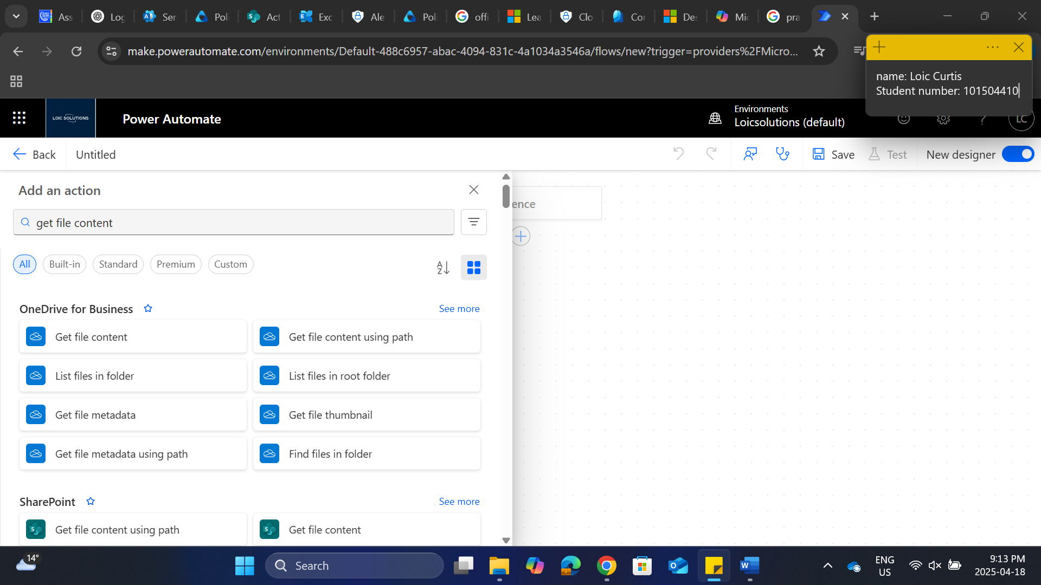

Select the file identifier document for the report

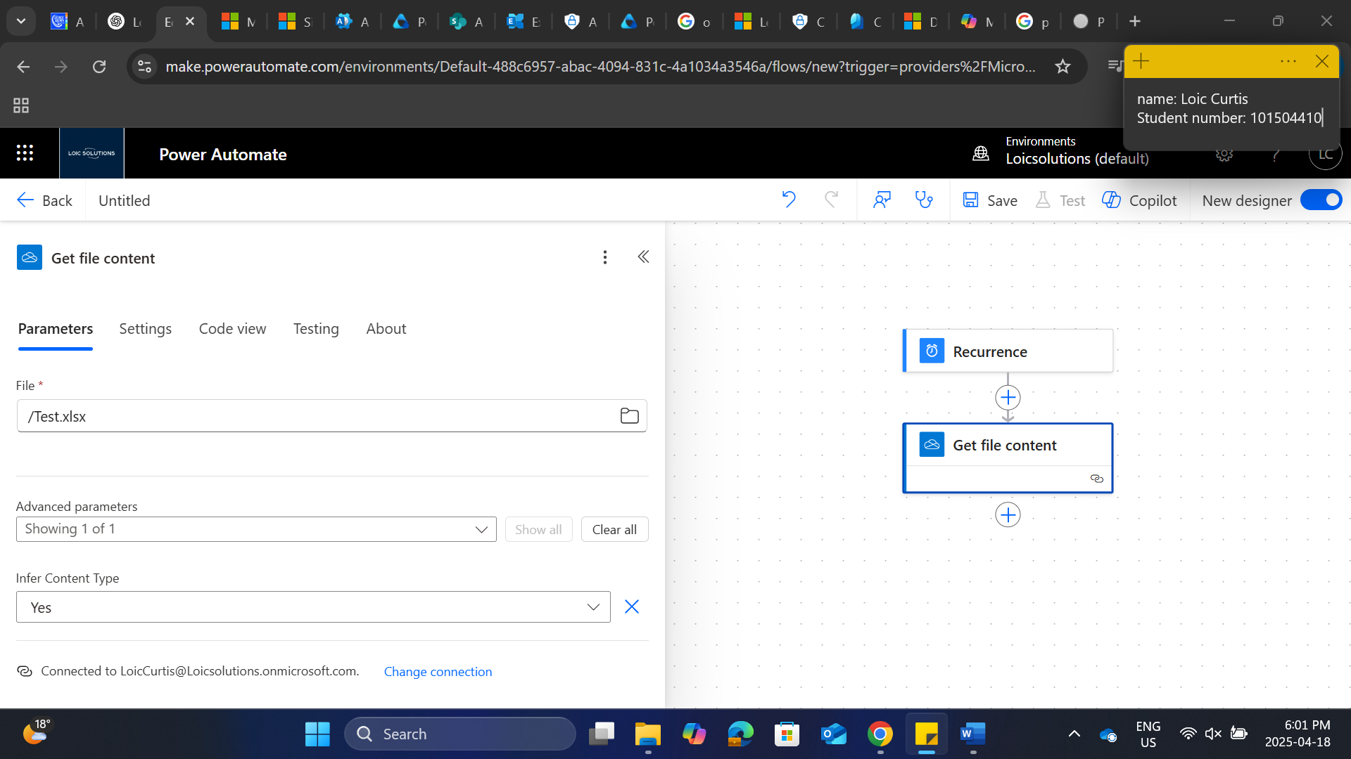

Select the plus sign under get file content



Select outlook

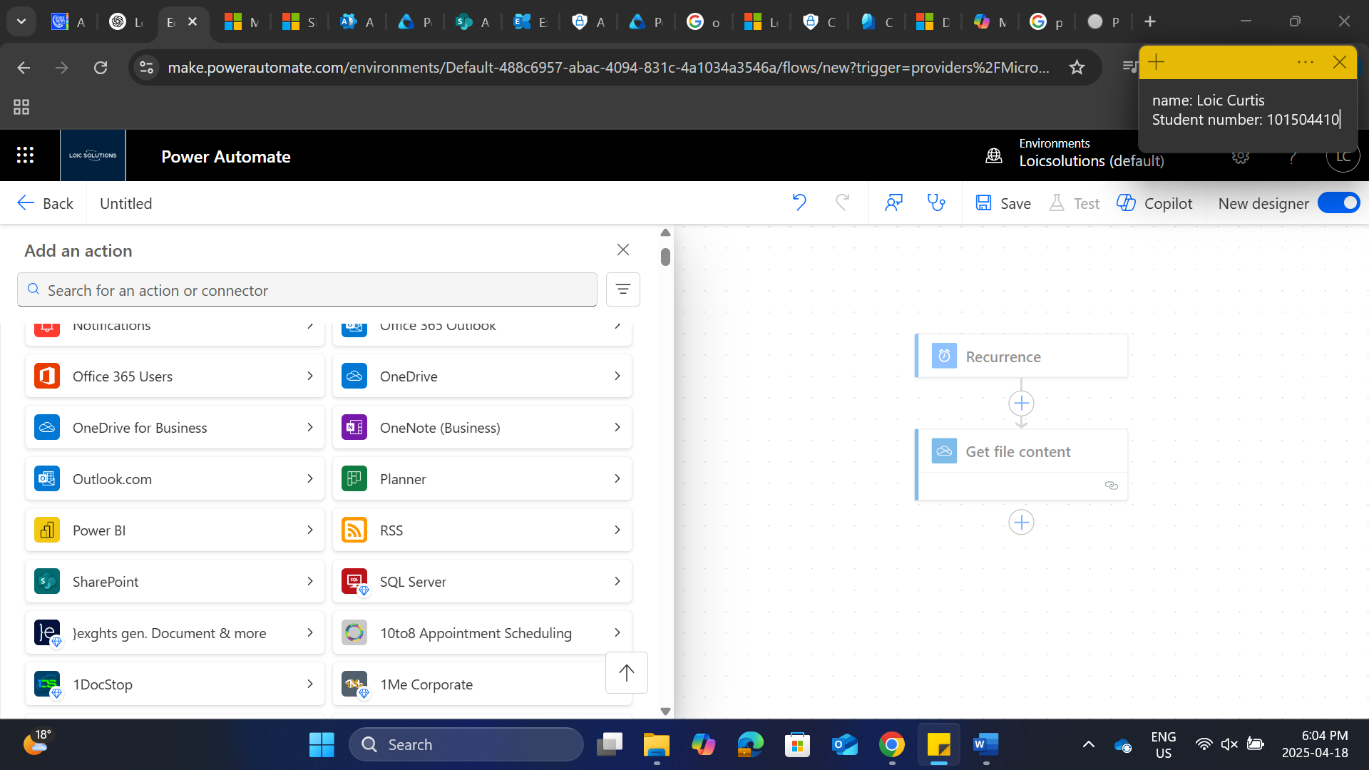

Select send an email v2 and signing into outlook to establish connection

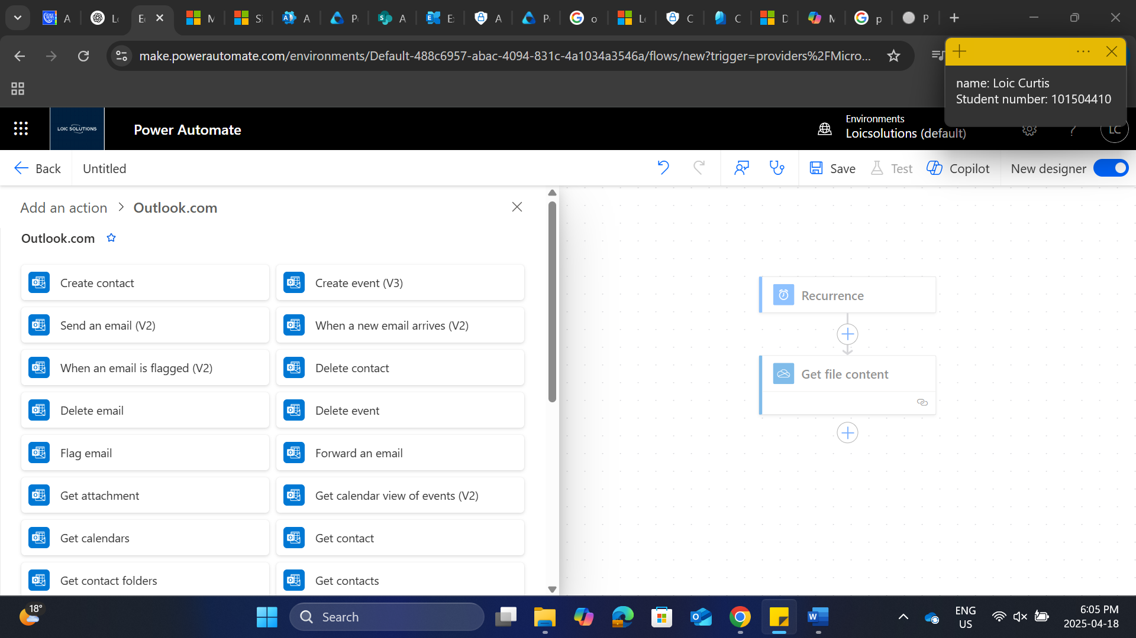

Send to you can put your global admin and an additional manager to view the reports

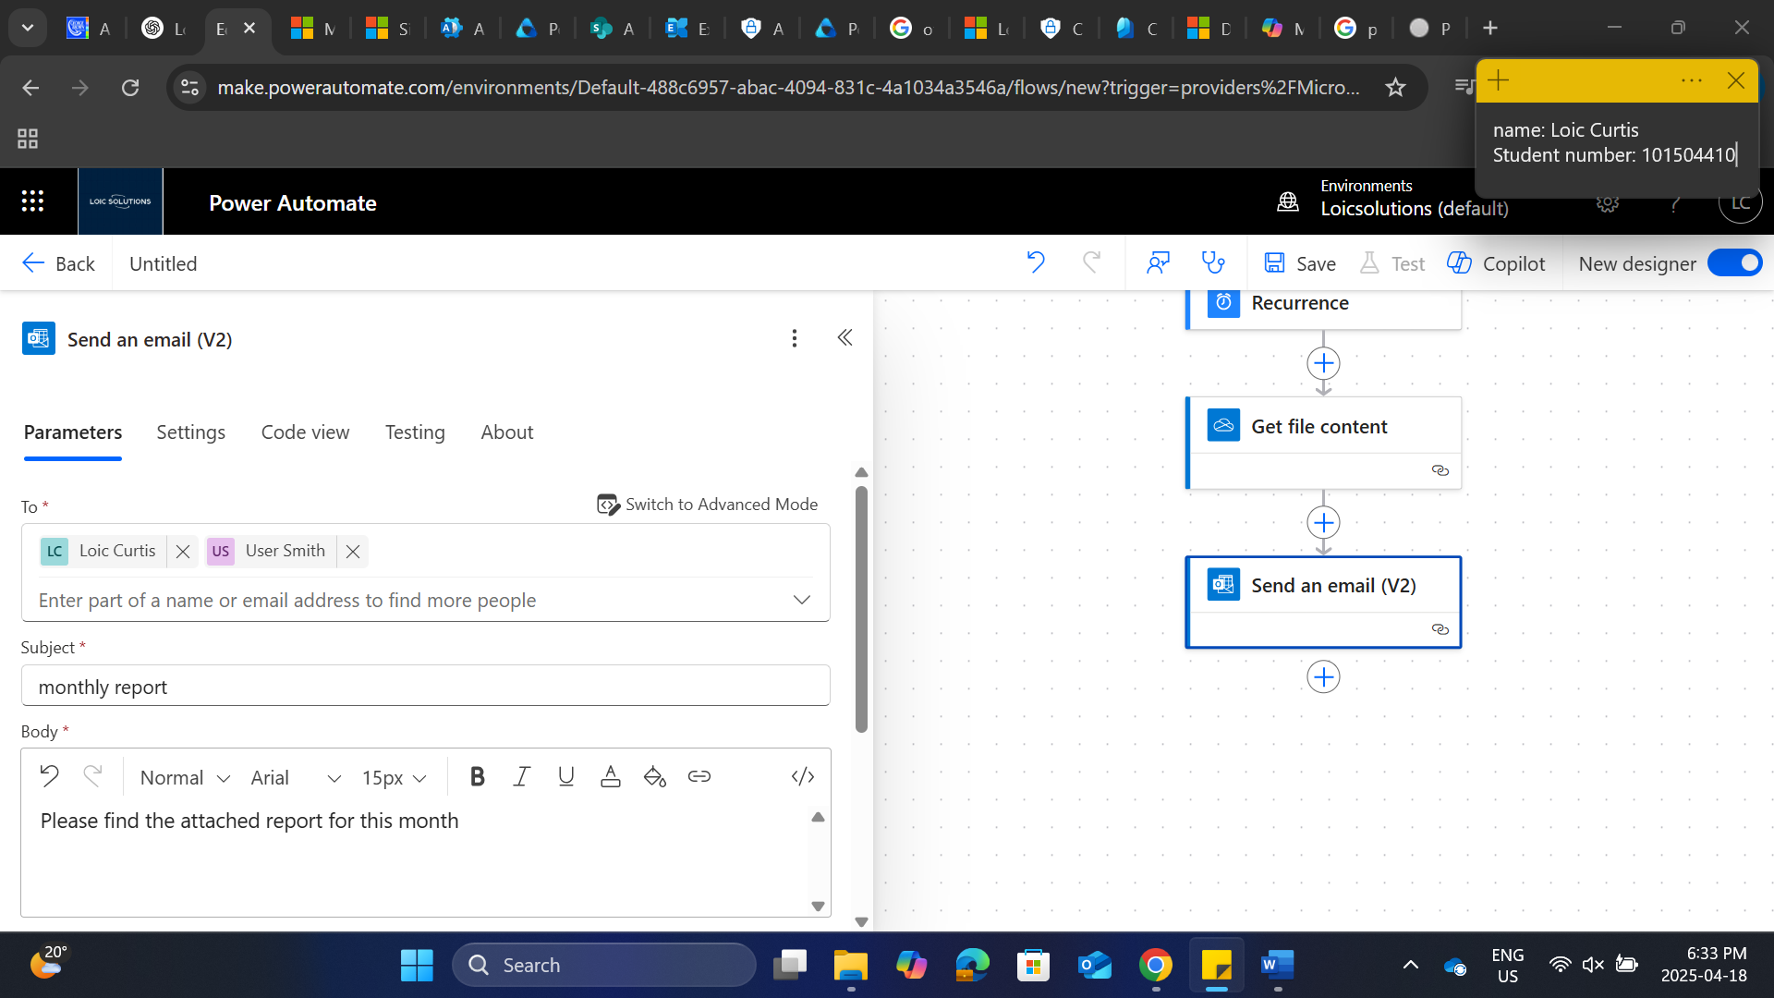

Scroll down under advance parameters and select attachments

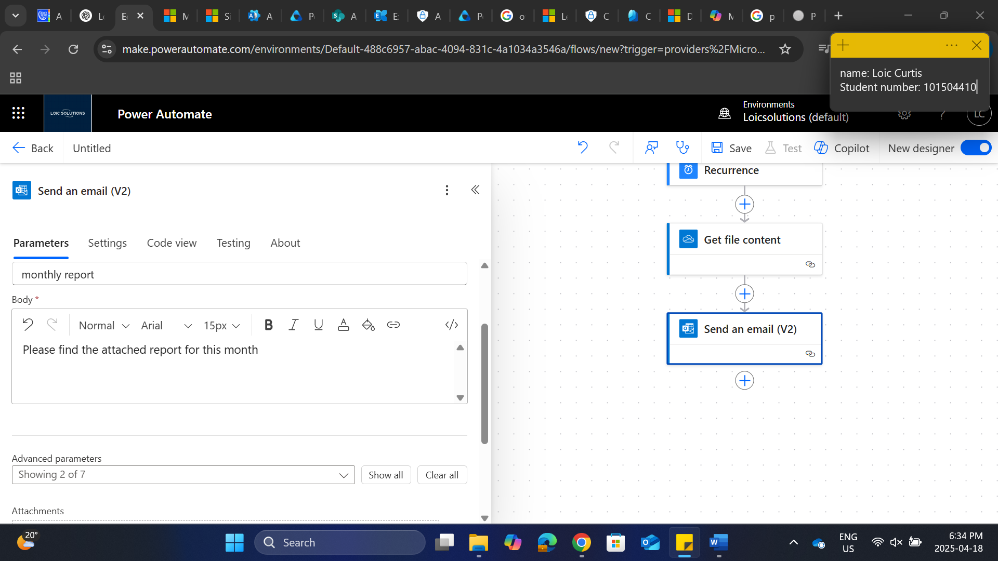

Select add new item

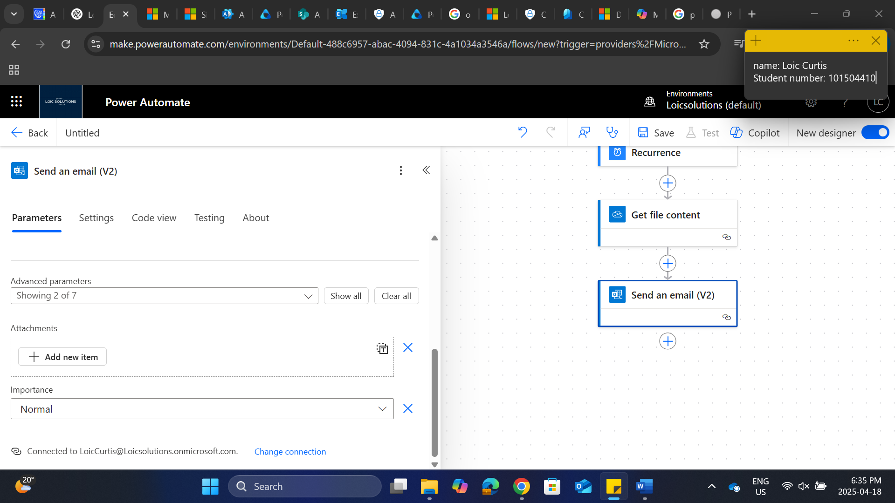

Put your attachment name, for content input / to enable dynamic expression and you’ll see the option to add file content

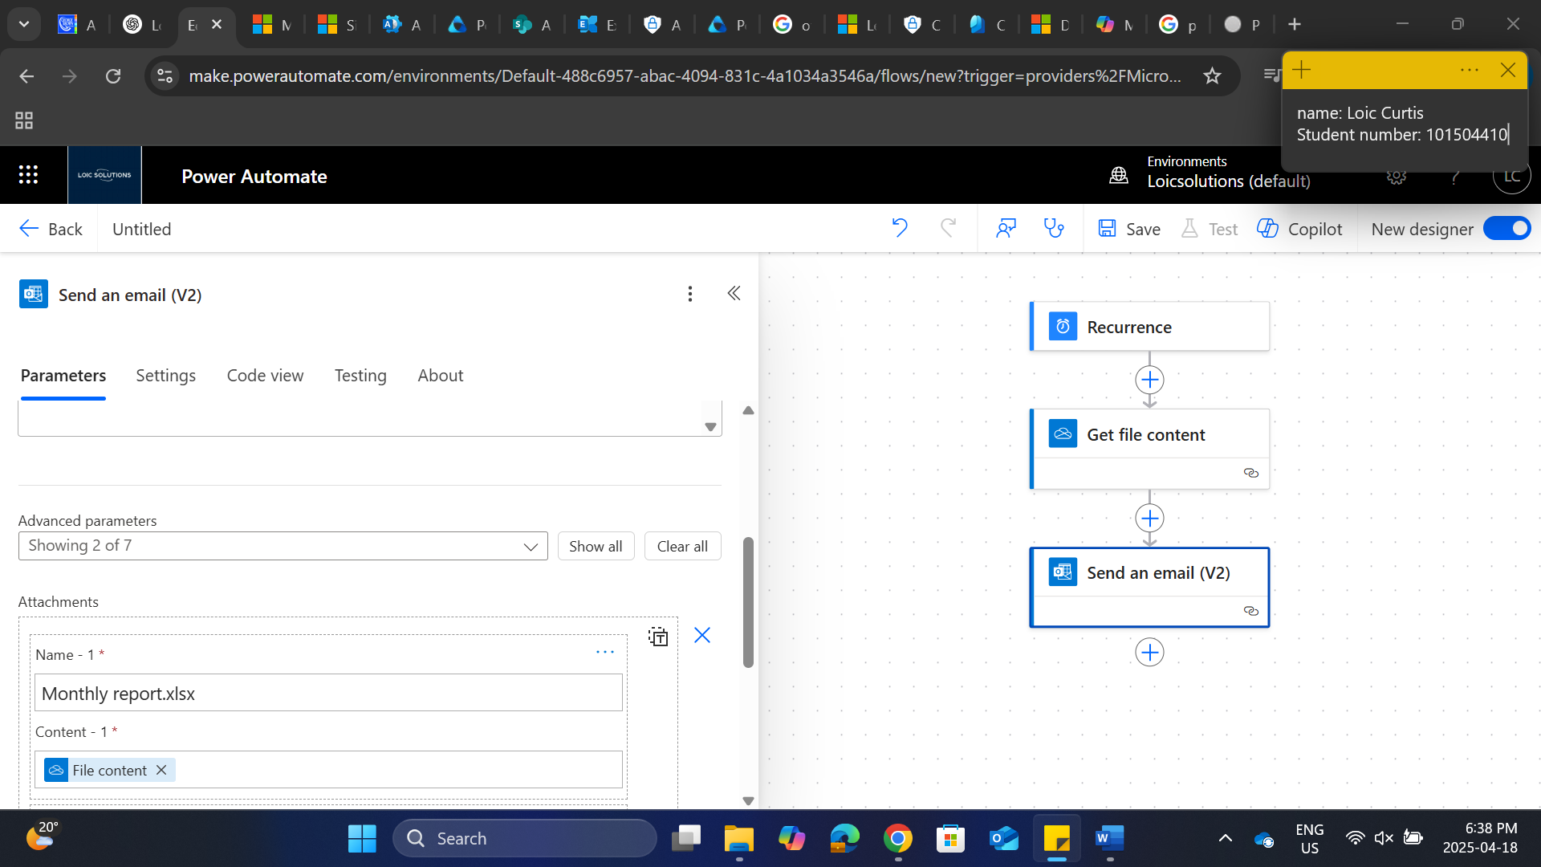

Select save

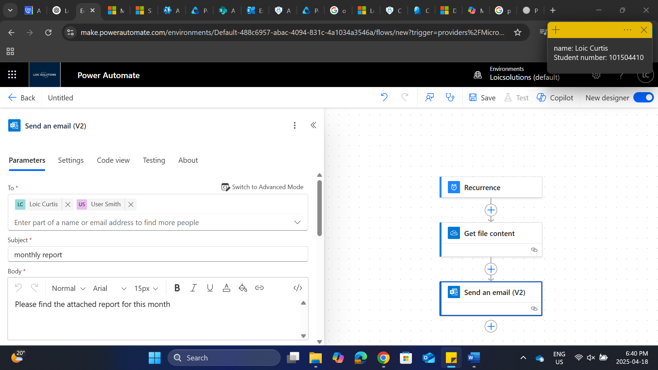

Select test flow at the top, manual

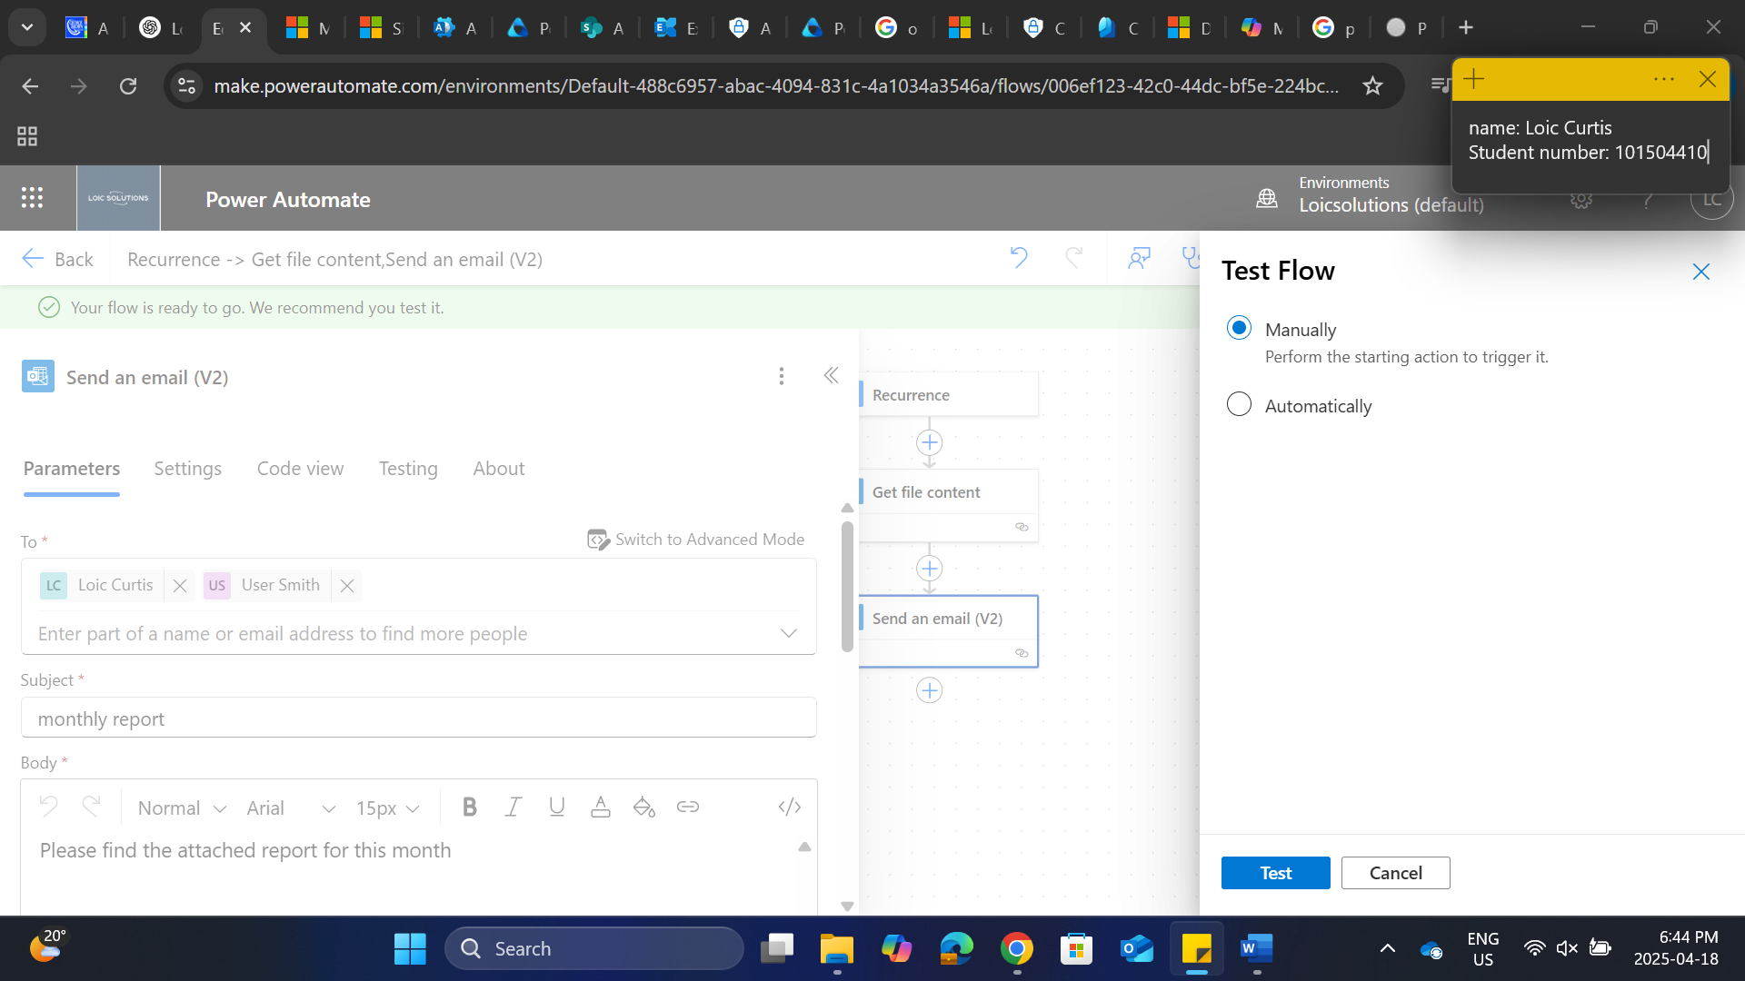

Flow was a success

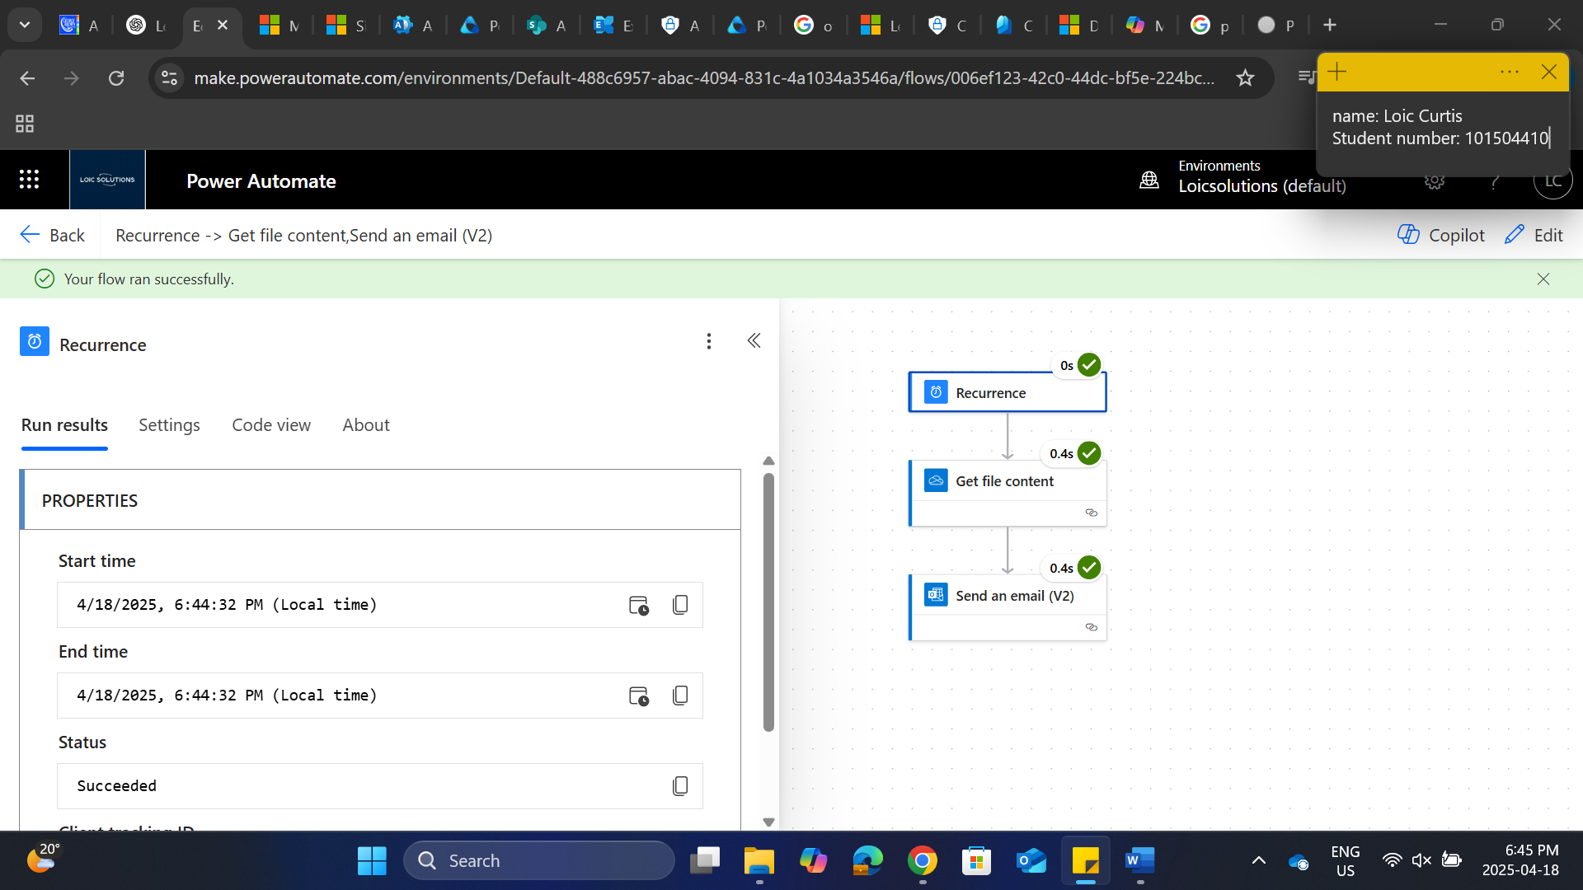

1. **Implement and Monitor Service Health**:

Open 365 admin center and click service health

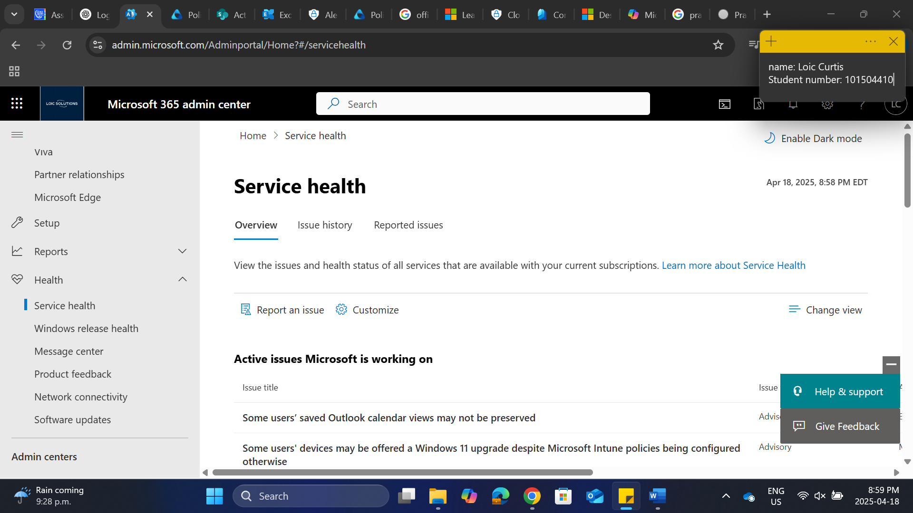

Select customize and go the email option

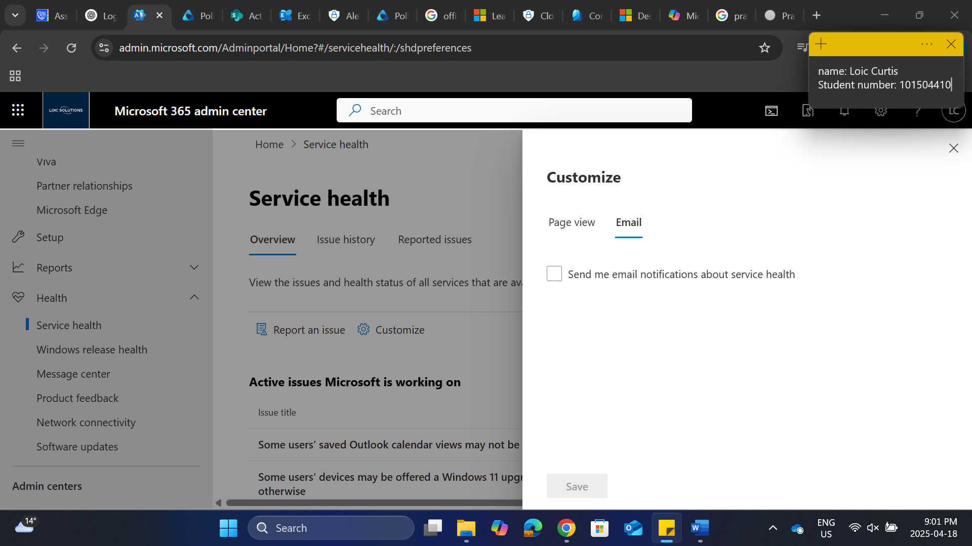

Enable send me email notifications about service health and you can add different email addresses for the notifications

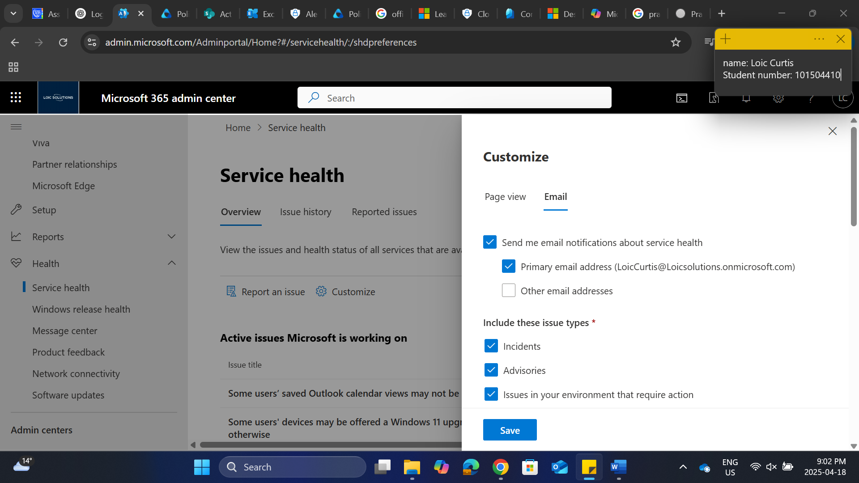

Our service health dashboard shows most of our services are healthy

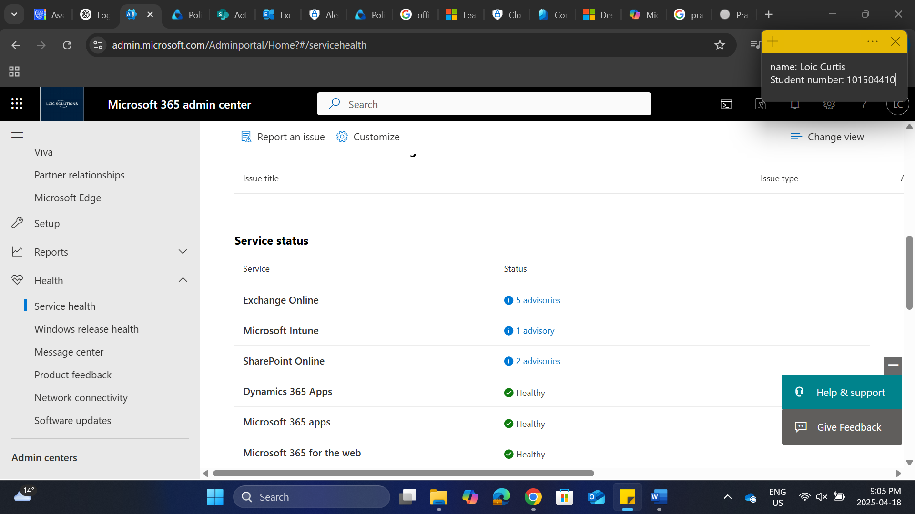

We have a few advisories on the health dashboard. This has minimal impact and happens sometimes due to updates

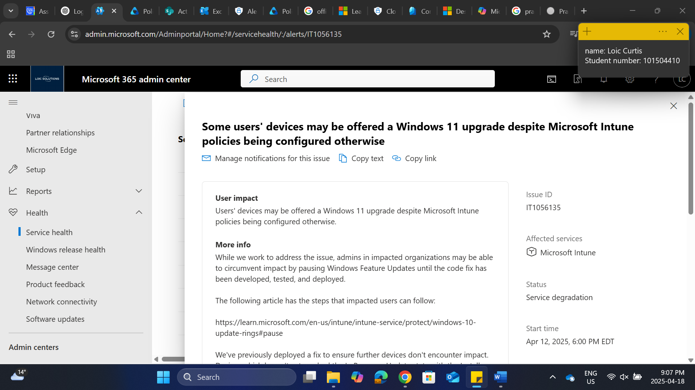

**Task 1: Setting Up and Configuring User Accounts**

For task 1, I worked on setting up and configuring user accounts within Microsoft 365. The bulk import of users from a CSV file was straightforward, I used the csv notepad file. The csv for users could be done with an excel csv file as well. This enabled me to quickly add multiple users and assign Microsoft 365 E5 licenses. Configuring user profiles involved ensuring each user had a profile picture, contact information, and job title, which helped personalize their accounts and facilitate better communication and identification within the organization. I created Office 365 groups for IT, HR, and Marketing to be used by the members of their respective departments and assigned specific permissions to ensured that sensitive HR documents were secure.

**Task 2: Monitoring and Reporting**

In this task, configuring audit logs in the Microsoft 365 compliance center allowed me to track user activities, providing valuable insights into user behavior. Setting up alert policies to notify administrators of suspicious activities, like mass file deletions, helped in promptly addressing potential security threats. Generating usage reports on user activity, email usage, and SharePoint site usage provided me an understanding of organizational operations, and scheduling monthly reports ensured that IT administrators and department heads were kept informed. Implementing and monitoring service health alerts ensured that any issues with Microsoft 365 services were promptly addressed, maintaining smooth operations. And checking for the advisory notifications on the health dashboard to check the severity and possible outcome of the health status alert.